**CASE STUDY: IMPACT OF *HYPODERMA LINEATUM* UPON LIVE GROWTH, CARCASS ATTRIBUTES, AND HIDE VALUE OF FED BEEF CATTLE**

By:

Daniel E. Guadián García

A THESIS

submitted in partial fulfillment of the requirements for the degree

MASTER OF SCIENCE

Major Subject: Agriculture

Emphasis: Animal Science

Department of Agricultural Sciences

West Texas A&M University

Canyon, TX

December 2016

**ABSTRACT**

A case study was done at the West Texas A&M University Research Feedlot, Canyon, from 14 November 2014 to 5 August 2015. While processing crossbred bulls (n=32) upon arrival (d0), some animals in the load of cattle were identified to be infested with grubs, later identified as the common cattle grub, *Hypoderma lineatum* (Villers). Metaphylaxis was administered upon arrival (d 0) to the feedlot; additionally, cattle were vaccinated against respiratory viruses, dewormed, and individually identified. Cattle were placed on a starter ration (d0) and transitioned to a finishing ration by d45. Twelve days after arrival, all cattle were re-weighed and manually palpated to quantify infestation by grubs; a hide map was used to record the location of the individual grubs. Grubs were manually extracted from the left side of infested animals to assess potential need for physical removal; right side grubs remained in the animals. Also, on d12, animals were administered a growth-promoting implant, and band-castrated. Two grub-infested cattle were slaughtered (d18) at the WTAMU Meat Laboratory to document hide damage; hides were manually fleshed and converted into rawhide. Two animals (grub-free) died from bovine respiratory disease during the study period (d15, d50). The remaining cattle were reweighed (d12, d40, d70, d96, d124, d152, d180, d208, d234, d236, and d264) to assess potential differences in growth rate. Cattle were slaughtered in two groups (n=9 on d234; n=19 on d264) at a local beef processor. Data collected during slaughter and grading processes included individual animal identification, liver score, hot

carcass weight, longissimus muscle area, 12th rib subcutaneous fat depth, kidney-pelvic-heart fat, yield grade, marbling score, and quality grade. Hides were individually identified and tracked through the facility to hide processing. Hides were green de-fleshed, lime de-fleshed, and de-haired for 24 h. Hides were then exposed to blue-chroming chemicals for 24 h; subsequently, blue-chrome hides were individually graded as #1, #2, or #3 hides. No difference in initial weight (*P* = 0.89), finished weight (*P* = 0.35), average daily gain (*P* = 0.59), hot carcass weight (*P* = 0.38), longissimus muscle area (*P* = 0.91), 12th rib subcutaneous fat depth (*P* = 0.64), calculated yield grade (*P* = 0.84), or kidney-pelvic-heart fat (*P* = 0.38) was detected between grub-free and grub-infested cattle. Grub-infested cattle tended to have more marbling (*P* = 0.07) than grub-free cattle. No difference in hide damage or value occurred between left sides (manually extracted) and right sides (grubs allowed to remain). Infestation by grubs did not negatively affect growth or carcass attributes. Hide damage in feeder calves resolved during the finishing period and grub-damaged hides met #1 criteria. Timely application of avermectin can prevent this problem from reducing beef system value.

**ACKNOWLEDGMENTS**

This thesis is dedicated to my parents who have given me the opportunity of an education from the best institutions and support throughout my life.

This master’s thesis would not have been possible without the guidance and the help of several individuals who in one way or another contributed to my education and contributed their valuable time and effort in the development and completion of this study. I wish to thank the members who served on my thesis committee, Dr. Ty Lawrence, Dr. Bonnie Pendleton, and Dr. John Richeson. I am heartily thankful to my supervisor, Dr. Ty Lawrence, whose encouragement, guidance and support from the initial to the final levels enabled me to develop an understanding of agriculture. I am very thankful to him for believing in me and giving me an opportunity to complete a master’s program under his supervision.

Last but not the least; I want to thank my family and the One above all of us, for giving me the strength to continue fighting every day to better myself as an animal scientist as well as a person. I am indebted to everyone who has been a part of the one and only, Beef Carcass Research Center for continuous support throughout my educational career as well as this project.

# **APPROVAL**

**___________________________________________________**

Chairman, Thesis Committee Date

**___________________________________________________**

Member, Thesis Committee Date

**___________________________________________________**

Member, Thesis Committee Date

**______________________________________________________**

Head, Department of Agricultural Sciences Date

**______________________________________________________**

Dean, College of Agriculture and Natural Sciences Date

**______________________________________________________**

Dean, Graduate School Date

# **TABLE OF CONTENTS**

TABLE OF CONTENTS v

LIST OF FIGURES vii

LIST OF TABLES ix

CHAPTER 1 1

INTRODUCTION 1

CHAPTER 2 3

REVIEW OF LITERATURE 3

2.1 History of the cattle grub 3

2.2 Development and life cycle of heel flies 4

2.3 Seasonal occurrence 12

2.4 Historical impact of cattle grubs 16

2.5 Losses due to cattle grubs 17

2.6 Factors of nature affecting grubs 18

2.7 Housing and protection against heel flies 19

2.8 Methods to control cattle grubs 19

2.8.1 Controlling grub infestation by manual removal 19

2.8.2 Dipping vats 20

2.8.3 Rotenone 21

2.8.4 Organophosphates 23

2.8.4.1 Ruelene 24

2.8.4.2 Warbex 25

2.8.5 Avermectins 26

2.8.6 Milbemycins 29

2.9 Immune response and vaccination 29

2.10 Bibliography 31

3.1 INTRODUCTION 47

3.2 ABSTRACT 47

3.3 Materials and methods 50

3.3.1 Initial discovery and cattle processing 50

3.3.2 Manual removal, castration, and further processing 51

3.3.3 Harvest in meat laboratory 51

3.3.4 Live animal growth 52

3.3.5 Commercial slaughter and animal processing 52

3.3.6 Statistical analysis 53

3.4 Results and discussion 53

3.4.1 Meat laboratory harvest 53

3.4.2 Growth performance 54

3.4.3 Carcass attributes 54

3.4.4 Hide damage 55

3.5 Conclusion 55

3.6 BIBLIOGRAPHY 57

APPENDICES 64

# **LIST OF FIGURES**

FIGURE 2.1

Adult male heel fly 4

FIGURE 2.2

Fly laying eggs on a host 4

FIGURE 2.3

Eggs of the common heel fly 5

FIGURE 2.4

Egg of the northern heel fly 5

FIGURE 2.5

First-stage larva of the common cattle grub. In this stage, insects come beneath the skin of the backs of cattle 6

FIGURE 2.6

Position of the cattle grub underneath the skin 8

FIGURE 2.7

Graphic demonstration of the life cycle of the common cattle grub. The seasonal occuarance is shown approximately as it occurs according to the latitude 13

FIGURE 2.8

Approximate dates of first appearance of the common cattle grub in the backs of cattle. 14

FIGURE 2.9

Livestock showing discomfort as grubs start penetrating through the skin 15

FIGURE 2.10

Tool developed to manually remove cattle grubs 20

FIGURE 2.11

Dipping vats containing arsenic solution or 2% coal-tar creosote solution used in the 1900’s 21

FIGURE 3.1

Cattle grubs and hide damage in a feeder calf harvested at the WTAMU Meat Laboratory (d18) 60

FIGURE 3.2

Individually identified blue chrome hide from a grub-free animal 61

FIGURE 3.6

Cattle grub on hide at slaughter (d264) 62

FIGURE 3.7

Hole from cattle grub in blue chrome hide at slaughter (d264) 63

**LIST OF TABLES**

TABLE 3.1 Median ± quartile deviation of initial weight, average number of grubs, periodic average daily gain, finished-weight, and total ADG of grub-free cattle and grub-infested cattle 60

**CHAPTER 1**

## INTRODUCTION

Cattle grubs (*Hypoderma lineatum* (Villers) and *Hypoderma bovis* (Linnaeus) are a topic in the beef industry that has not been a contemporary issue because of modern methods of control. The adult stage, called a heel fly, can reduce cattle comfort and impact daily growth, whereas the immature grubs can damage the hide and lessen its value (Bishopp et al., 1944). Today, two species of cattle grubs are common in the U.S.; the most widespread is the common cattle grub, *Hypoderma lineatum,* which has become established in every state, and the other is the northern cattle grub, *Hypoderma bovis*, which in the 1920’s had not reached the southern part of the country (Bishopp et al., 1944). The northern cattle grub is more limited in distribution and as of 2013 was found primarily north of a line running across the country, from northern California through Kansas to the Carolinas. Historically, populations of the northern cattle grub have been reported in central Florida on cattle shipped in from more northern states. Infestations of native cattle with the northern cattle grub suggest the insect is an established pest in Florida (Kaufman and Weeks, 2013). Heel flies develop from grubs that have dropped from the backs of cattle. Common heel flies appear during the first warm days of spring and their activity increases as the season advances, until at the end of about 6 weeks the last of them has disappeared (Scholl, 1993). Heel flies usually attach themselves low on the legs, particularly above the hoof. The flies locate themselves very close to the skin and deposit as many as 300 eggs, which are attached firmly to the hair of the animal. This is why the name “heel fly” has been used throughout time. Control of cattle grubs or heel flies was one of the most important insect problems confronting the U.S. cattle industry at until the 1960’s (Bishopp et al., 1944).

# **CHAPTER 2**

## REVIEW OF LITERATURE

### 2.1 History of the cattle grub

Cattle grubs, also called wolves or warbles are the larval or maggot stage of insects also known as heel flies, warble flies, or gadflies (Bishopp et al., 1926). Hypodermosis of cattle is caused by larvae of flies whose scientific classification is the following: kingdom Animalia, phylum Arthropoda, class Hexapoda, order Diptera, family Oestridae, subfamily Hypodermatinae, and genus *hypoderma.* Two major species of *hypoderma* are found between 25 and 60° latitudes in the northern hemisphere and are present in more than 50 countries on the continents of Africa, America, Asia, and Europe (Aiello and Mays, 1998). The species are *Hypoderma bovis* (Linnaeus, 1758) and *Hypoderma lineatum* (De Villers, 1798). The grubs can cause major damage that affects the cattle industry, including dairies, meat packers, hide tanners, and even consumers. This parasite decreases weight gain and milk production, as well as causes economic loss in hides (Pandero et al., 1997). All of these effects on the animal can be directly attributable to the larvae that are migrating through the tissue in the host (Andrews, 1978; Drummond, 1987). In the United States, there are two species of cattle grubs that have similar habits. The most common cattle grub is *Hypoderma lineatum,* which has become established in every state of the U.S. and is known as the “common cattle grub”. This

species is also found in Canada and northern Mexico. *Hypoderma bovis*, which has become known as the “northern cattle grub”, is typically found north of the 35th parallel (Aiello and Mays, 1998).

### 2.1 Development and life cycle of heel flies

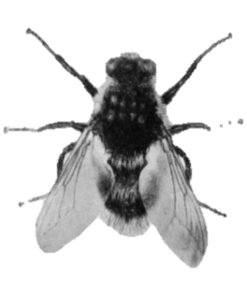

**Figure 2.2** Adult female heel fly ~15mm long.

Bishopp, F. C. (Fred Corry), 1884-1970.; Laake, E. W. (Ernest William), 1887-1986. & Wells, R. W. (Roscoe Ward), b. 1890. Cattle grubs or heel flies with suggestions for their control. Washington D.C. UNT Digital Library. <http://digital.library.unt.edu/ark:/67531/metadc1750/>. Accessed 11 April 2016.

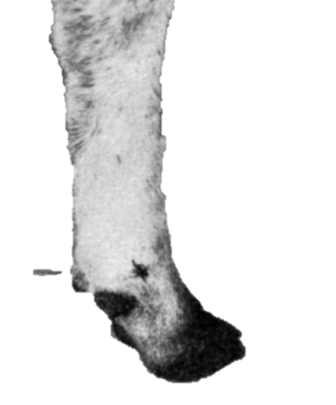

**Figure 2.2** Fly laying eggs on the lower legs of a host.

Bishopp, F. C. (Fred Corry), 1884-1970.; Laake, E. W. (Ernest William), 1887-1986. & Wells, R. W. (Roscoe Ward), b. 1890. Cattle grubs or heel flies with suggestions for their control. Washington D.C. UNT Digital Library. <http://digital.library.unt.edu/ark:/67531/metadc1750/>. Accessed 11 April 2016.

If the animal is lying down, heel flies may attach themselves to the hair coat in the area below the vulva and along the hair of the udder and belly. The eggs of the common cattle grub are usually attached one above another in a cluster (Figure 2.4), and those of the northern species are attached singly one at a time (Figure 2.5).

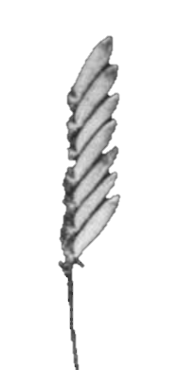

**Figure 2.3** Eggs of the common heel fly ~0.8 mm long and 0.25 mm wide.

Bishopp, F. C. (Fred Corry), 1884-1970.; Laake, E. W. (Ernest William), 1887-1986. & Wells, R. W. (Roscoe Ward), b. 1890. Cattle grubs or heel flies with suggestions for their control. Washington D.C. UNT Digital Library. <http://digital.library.unt.edu/ark:/67531/metadc1750/>. Accessed 11 April 2016.

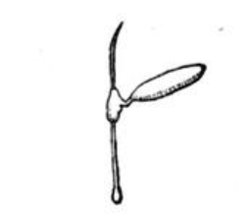

**Figure 2.4** Eggs of the northern heel fly 0.8 mm long and 0.25 mm wide.

Bishopp, F. C. (Fred Corry), 1884-1970.; Laake, E. W. (Ernest William), 1887-1986. & Wells, R. W. (Roscoe Ward), b. 1890. Cattle grubs or heel flies with suggestions for their control. Washington D.C. UNT Digital Library. <http://digital.library.unt.edu/ark:/67531/metadc1750/>. Accessed 11 April 2016.

.

Warmth of the body of the host allows the eggs to hatch within 3 to 7 days (Bishopp et al., 1944); the larva (~1 mm in length) emerges from the egg shell and forces its way into the skin and into deeper tissues (Carpenter and Hewitt, 1914; Aiello and Mays, 1998). Inflammation usually occurs at the penetration site (Gingrich, 1982). Once the larva enters the host, first-stage larvae (Figure 2.6) slowly migrate through tissues while feeding and growing for about 4-6 months (Hadwen and Bruce, 1916).

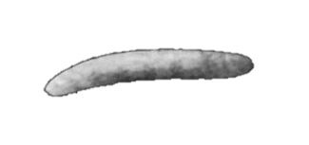

**Figure 2.5** First-stage larva of the common cattle grub. In this stage insect comes beneath the skin of the backs of cattle 0.8 mm long and 0.25 mm wide

.

Bishopp, F. C. (Fred Corry), 1884-1970.; Laake, E. W. (Ernest William), 1887-1986. & Wells, R. W. (Roscoe Ward), b. 1890. Cattle grubs or heel flies with suggestions for their control. Washington D.C. UNT Digital Library. <http://digital.library.unt.edu/ark:/67531/metadc1750/>. Accessed 11 April 2016.

*Hypoderma lineatum* larvae travel from the posterior of the animal to a “resting site”, which is submucosal connective tissue of the esophagus, in the anterior of the animal (Beesley, 1961, 1974). The larvae can be found in the connective tissue on the surface of organs in the abdomen and in-between the mucous and muscular layers of the gullet and spinal canal (Bishopp et al., 1926).

After approximately 8 months, late first-instar larvae (~15 mm in length) leave the “resting site” and migrate to the mid-dorsal region of the animal (Hadwen and Bruce, 1916); once there, they place themselves in the connective tissue just beneath the skin (Simmons, 1939). When they reach this location, they open respiratory holes in the skin of the host and a cyst forms around the larva (Scholl, 1993). The entire migration cycle from the time eggs hatch to arrival at the back is approximately 8 to 9 months (Scholl, 1993).

The adult or fly stage of the common cattle grub is similar in appearance to the common horse bot fly or nit fly, but smaller in size, measuring about 1.2 cm in length (Bishopp et al., 1944). The common heel fly has a wing expansion of almost 2.5 cm and is darker in color (Bishopp et al., 1944). Most of the body is covered with black hairs, but there is a band of orange and yellow hairs across it (Bishopp et al., 1926). The head is covered in yellowish-white hairs in the front and side parts (Bishopp et al., 1944). During the fly stage, the northern species is somewhat larger and stouter than the other species (Bishopp et al., 1944). The band of hairs on the tip of the stomach is paler and somewhat broader. Although the flies were very abundant and seen in many pastures in the United States decades ago, they are very rare today. The habits of the two kinds of grubs were similar. Heel flies begin attacking cattle for the purpose of laying eggs during the first sunny days of spring (Bishopp et al., 1926). Flies tend to approach animals in pastures or in barns. Northern heel flies appear about a month later, and their activity is extended over a longer period. They prefer cloudy days and showers. Grubs of this species are most abundant in the backs of cattle (Figure 2.7) after those of the common heel fly have disappeared (Bishopp et al., 1944). It has not been uncommon for some northern grubs to be found in cattle during the month of August (Bishopp et al., 1926). Both male and female flies live for only a couple of days, and it is rare for them to live for longer than a week (Bishopp et al., 1944). The flies have no mouthparts and also no need for food (Bishopp et al., 1944). After mating, the females have only one purpose and that is to deposit eggs on the hairs of cattle. Cattle sense their presence and touch and become bothered (Bishopp et al., 1926).

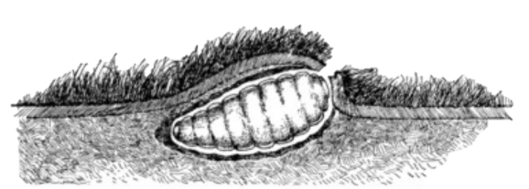

**Figure 2.6** Position of the cattle grub underneath the skin ~28 mm long and 13 mm wide.

Bishopp, F. C. (Fred Corry), 1884-1970.; Laake, E. W. (Ernest William), 1887-1986. & Wells, R. W. (Roscoe Ward), b. 1890. Cattle grubs or heel flies with suggestions for their control. Washington D.C. UNT Digital Library. <http://digital.library.unt.edu/ark:/67531/metadc1750/>. Accessed 11 April 2016.

Tickling caused by the flies is perceived by the animal being attacked; animals that are under attack reportedly shake and kick to try and rid themselves of the flies (Bishopp et al., 1944). The flies usually attack again and at this point cause the animal to start using its tail for protection (Bishopp et al., 1944). In dairy cattle, flies might attack the animal while it is lying down and this might not disturb the animal (Bishopp et al., 1926). The flies do not sting or cause any pain to the cattle (Bishopp et al., 1926). The flies tend to lay their eggs only on sunny days, although the northern species may also lay eggs after it has rained on cloudy days (Bishopp et al., 1926). Flies usually do not deposit eggs during a breeze, but they seem to not be bothered by cool temperatures between 4° and 7° C (Bishopp et al., 1944). Throughout history, people have believed that shade will protect the animal against flies; however, shade seems not to give animals any protection (Bishopp et al., 1944). Heel flies usually begin laying their eggs from 0900 to 1000 h in the morning and this may continue until sundown, but most of the time it stops late in the afternoon (Bishopp et al., 1944). During very hot weather, heel flies are less active in the afternoon (Bishopp et al., 1944). Eggs deposited on the animal are yellowish white and have a smooth and shiny surface (Bishopp et al., 1926). The eggs are narrow and their length is fairly equal to that of the egg of the common horse bot fly or nit fly (Bishopp et al., 1926). The bottom portion of the egg contains a clamp, which secures the egg to the hair (Bishopp et al., 1926). Eggs are not often seen by stockmen because they are attached close to the skin and are surrounded by hairs. When the larva penetrates the skin, a small amount of serum is usually excreted, which causes the hair to come together and with the irritation in the skin produces a scab. During the fall, winter, and spring, grubs migrate through the muscular tissues of the back and in a short amount of time reach the under surface of the skin. During the last passage, some of the grubs enter the spinal canal and may hideaway along the spinal cord. At this time the larvae are very slim and white, measuring 1.7 to 2.54 cm in length (Bishopp et al., 1944). The larva is very smooth, except for spines at each end. One to five days later, the grub molts its skin for a third time. After the molt, the skin is set closely with spines. The host body begins to isolate the invading parasite and a small pocket or cyst is developed from the tissues of the host; the cyst is formed around the larva and remains for as long as five weeks or longer (Bishopp et al., 1944). As the larva grows, it causes swelling that becomes very noticeable and the bumps become obvious in the back of the animal. During the last stage, the color gradually darkens, first becoming yellowish, then brown, and finally turning black.

Penetrating through the skin, a breathing hole is kept open to the surface, and the grub lies with its two breathing pores on the tail end, close to the opening of the skin. As growth occurs, the hole in the skin becomes larger. After the end of development in the back, which requires 35 to 90 days, growth is complete, and the grub works its way out and falls to the ground (Bishopp et al., 1926). The northern cattle grub develops in a similar way, but seems to require a period of at least 60 to 110 days in which to complete its growth in the back (Bishopp et al., 1926). An estimated 80% of northern grubs drop from the backs of animals during daylight, whereas the common cattle grub drops during the evening (Bishopp et al., 1926). After they pupate, some pupa go under the surface of the soil, some creep into narrow openings in rocks or underneath leaves, but many have been observed to pupate on the surface. Twelve to 48 hours after the grub has left the host, the outer skin of the grub becomes hard and blackish and forms a protective case inside which the grub changes into a heel fly (Bishopp et al., 1944). The length of this transformation varies with the temperature, ranging from 20 to 80 days for the common species and 15-25 days for the northern cattle grub (Bishopp et al., 1944). The fly emerges through a hinged flap at the upper forward end of the pupal case (Bishopp et al., 1944). Within 30 minutes after emerging, the wings of the fly have dried, and the fly is able to sustain itself on the wing. A few minutes later, the fly can fly freely and is ready to mate. The female may begin to drop fertile eggs on cattle about 15 minutes after mating, or only slightly more than an hour from emergence from the pupal case. When the flies crawl out from pupal cases, their abdomens are filled with food, which is stored from the grub stage. The food is sufficient to sustain the flies through their short span of life and enables them to develop eggs, making it unnecessary for them to feed in the adult or fly stage. During their short adult life span of 3–5 days (Zumpt, 1965; Papavero, 2012; Colwell et al., 2006), the antennal sensilla is the vital olfactory structures for *H. lineatum* and *H. bovis*. These sensilla are crucial to find mates and suitable hosts (de Freitas Fernandes et al., 2005; Amer and Mehlhorn, 2006; Smallegange et al., 2008; Guhaetal, 2012; Seenivasagan et al., 2012). The antennal sensilla of flies have developed many adaptive features to increase their sensitivity to attractive molecules in the constantly changing environment (Ismail, 1964; Ross, 1992; Sukontason et al., 2004; Zhang et al., 2012; Wang et al., 2014), because *H. lineatum* needs more sensitive olfactory organs to find specific mates and suitable hosts for oviposition (Papavero, 2012; Hunter and Adserballe, 1996; Colwell et al., 2006). Mechanoreceptors are suspected to receive mechanical signals caused by external stimuli of touch and air, which are involved in locomotion, posture, feeding, orientation, and oviposition (McIver, 1975; Bromely et al., 1980). Considering that *H. bovis* and *H. lineatum* are parasites with high host-specificity (Zumpt, 1965; Baker, 1967; Colwell et al., 2006; Papavero, 2012), the functions of the antennal sensilla are to trap odor molecules, facilitate odor detection, and enhance olfactory sensitivity (Jobling, 1928; Shanbhag et al., 1995; Hunter and Adserballe, 1996; Zhang et al., 2012). Although the antenna of *H. bovis* has been examined in past years, little is known about the antennal sensilla of adult *H. lineatum* (Hunter and Adserballe, 1996).The life cycle of the insect from egg to adult is about one year, keeping in mind there is only one generation per year in the case of bot species, although there is variation in the dates that different stages are present (Bishopp et al., 1944).

### 2.3 Seasonal occurrence

Seasonal occurrence (Figure 2.8) of different phases of the life of the cattle grub is of great importance in connection with control measures being used; differences between the two species exist with seasonal development. Several factors that can influence seasonal development include amounts of rainfall, methods of handling the animal, latitude, altitude, and amount of sunshine (Figure 2.9). Cattle raised at higher elevations in Texas, New Mexico, and Arizona have grub cycles similar to those in northern climates. Producers in those areas are familiar with when grubs appear in backs of their animals (Gojmerac, 1987). Common heel flies begin to appear and attack cattle during the first mild days of spring. In the southwestern United States, particularly in the plateau region of Texas, they occur earlier.

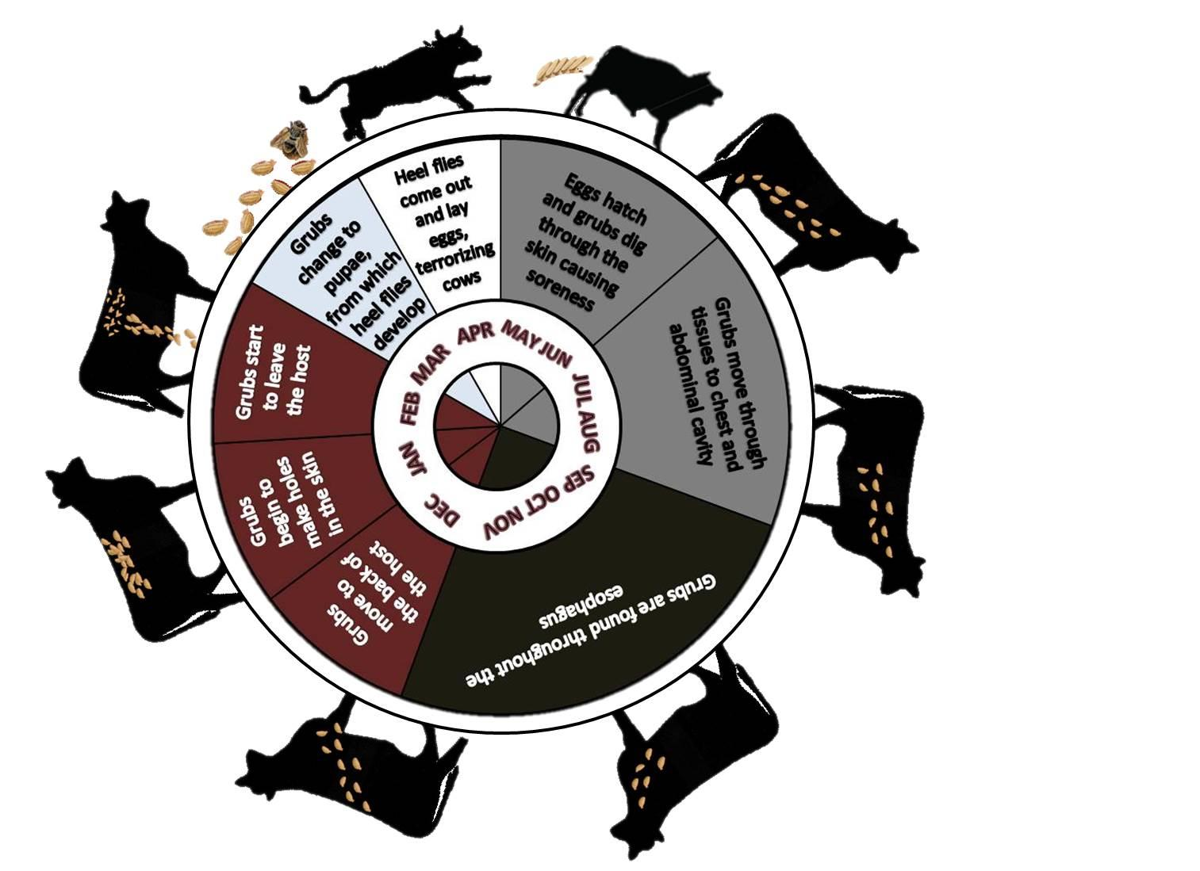

**Figure 2.7** Graphic demonstration of the life cycle of the common cattle grub. The seasonal occurrence is shown approximately as it occurs according to latitude levels.

Bishopp, F. C. (Fred Corry), 1884-1970.; Laake, E. W. (Ernest William), 1887-1986. & Wells, R. W. (Roscoe Ward), b. 1890. Cattle grubs or heel flies with suggestions for their control. Washington D.C. UNT Digital Library. <http://digital.library.unt.edu/ark:/67531/metadc1750/>. Accessed 11 April 2016.

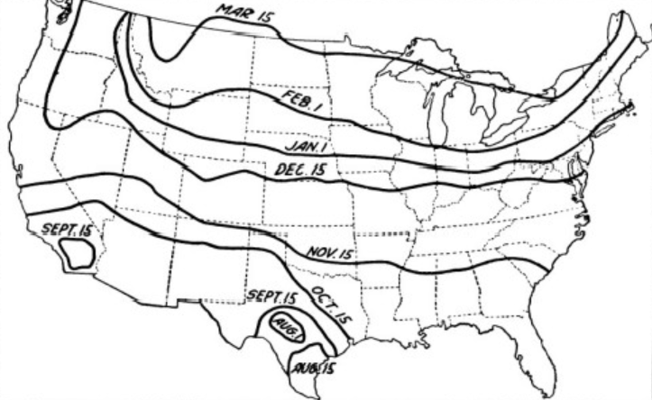

**Figure 2.8** Approximate dates of first appearance of the common grub in the backs of cattle.

Bishopp, F. C. (Fred Corry), 1884-1970.; Laake, E. W. (Ernest William), 1887-1986. & Wells, R. W. (Roscoe Ward), b. 1890. Cattle grubs or heel flies with suggestions for their control. Washington D.C. UNT Digital Library. <http://digital.library.unt.edu/ark:/67531/metadc1750/>. Accessed 11 April 2016.

Grubs can appear as early as August depending on the temperature and latitude (Figure 2.9), and continue to bother cattle during warm periods throughout the winter; this activity can continue until the first week of April. In the north, the first occurrence of the flies is later (Bishopp et al., 1926). Approximately two and a half months intervene between egg laying and the earliest appearance of young grubs in the esophageal area and elsewhere in the abdominal and chest cavities (Bishopp et al., 1926). Internal organs are infested by the grubs for a period of about nine months of the year. Maximum growth of the grubs on the internal organs occurs when they begin to migrate to the back of the animal. This can vary from year to year, but is usually during July or early August. The seasonal activity of the common cattle grub occurs as follows: during late March and early April, heel flies emerge and lay eggs, which terrorizes cattle. The eggs are placed upon the hairs of the animal in the month of April, the eggs hatch in May, and grubs dig through the skin causing sores that cows lick (Figure 2.10).

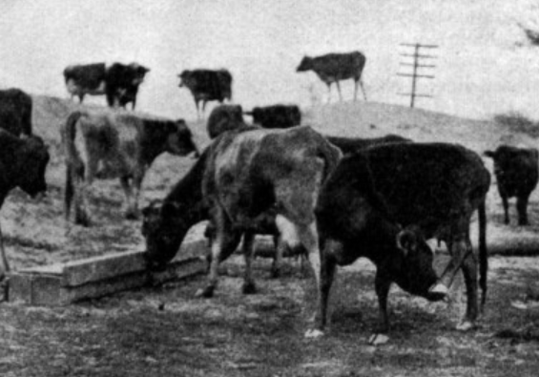

**Figure 2.9** Livestock showing discomfort as grubs start penetrating through the skin.

Bishopp, F. C. (Fred Corry), 1884-1970.; Laake, E. W. (Ernest William), 1887-1986. & Wells, R. W. (Roscoe Ward), b. 1890. Cattle grubs or heel flies with suggestions for their control. Washington D.C. UNT Digital Library. <http://digital.library.unt.edu/ark:/67531/metadc1750/>. Accessed 11 April 2016.

In June and July, tiny larvae move through tissues to chest and abdominal cavities. From August to early November, grubs are found in the walls of the gullet or weasand and become very abundant. In late November and early December, the grubs move toward the back of the animal and use enzymes capable of digesting skin to cut holes in the skin, to open a 3-mm-wide breathing hole where small bumps start occurring. Before January, grubs are growing in the back of the animals; some mature and drop out early, the rest drop out in February, when they change into pupae. When this final step occurs, the cycle starts over again (Bishopp et al., 1944). From an economic standpoint, the time when the first grubs mature and leave the cattle is of great importance. This date is correlated naturally with the date when the first grubs of the season reach the back. It is a rare occurrence for grubs to complete development in the back in a minimum of 35 days. Normally the first grubs are mature and leave the animals about 45 days after the holes first appear (Bishopp et al., 1926). Young larvae continue to reach the back during a period of several months, and in the meantime some of the older ones have matured and left the host. The period of infestation in the backs of the animals varies in different herds, but the most prevalent time for the common grub to be in the back of the animal is for four to five months. The northern cattle grub appears in the backs of cattle from one to five weeks later than the common species. Its development in the back is also slower, thus making the period of infestation in the north longer than where the common species alone is found.

### 2.4 Historical impact of cattle-grubs

One of the most important problems producers deal with is control of grubs. These insect pests have caused loss to dairymen, farmers, and ranchers. In the early 1920’s, controlling the insects was a very difficult task. They had not yet discovered any systematic way of controlling or eliminating the pests. The introduction of systemic organophosphorus insecticides in the 1950’s gave cattle producers the first opportunity to control cattle grubs for reasonable cost on a large scale (Scholl, 1993). Before this, cattle grubs were controlled by manual removal of second-and third-instar larvae from warbles or by the application of chemicals. The development of systemic insecticides gave producers an opportunity to kill migrating larvae before they arrived at the back of a host and avoid damage to hide and meat in that region (Scholl, 1993). Control of cattle grubs or heel flies is one of the most historically important insect problems that has confronted the cattle industry in the United States, and although the problem has been recognized as being very harmful to the industry, few of those involved with the industry actually understand the science behind the insects.

### 2.5 Losses due to cattle grubs

Losses caused by the insects have been difficult to determine and have been poorly tracked throughout the history of the industry. Damage by holes in the hides of the animals has been the major economic loss that cattle grubs cause to the industry (Batte, 1972; Everett et al., 1977). Swelling is caused in the back of cattle when grubs are numerous and pus starts to occur. This occasionally causes death (Bishopp et al., 1944). Some symptoms that occur in infested animals include bloating and vomiting (Scharff et al., 1962; Kahn, 1971). Because cattle are distressed, the flies can affect the level of finish compared to cattle without grubs. Greatest distress often occurs when the animals are weakest, during the spring. During this time many losses are encountered, cattle are very agitated because they are often standing in water or shade to gain relief, when they should be grazing. Carcasses from cattle that are slaughtered before the grubs have reached the back show easily visible symptoms in the areas affected (Bishopp et al., 1926). The areas appear as yellowish watery patches on the carcass, and require removal from the carcass. Meat quality is not affected by grubs, but the amount of trimming done to affected areas damages the appearance of the carcass and it is less suitable for sale (Bishopp et al., 1926). Carcass trimming not only diminishes weight, but increases labor needs, which economically affects the packer. Packers have stated that an average of two pounds of meat per carcass were removed by trimming (Bishopp et al., 1944). Another loss to packers occurs by the presence of grubs that appear near the weasand; weasands are typically punctured and not suitable for sausage casings, thus limiting their value (Bishopp et al., 1926). The biggest loss to a meat packer is diminished hide value lost to grubs. Before modern methods of control, it was common to find 40 to 100 holes in a hide affected by grubs (Bishopp et al., 1944). Even after the grubs left the back of the affected animal, the holes and scars remained in the hide which decreased hide value. For many years, leather manufacturers, tanneries, and hide dealers have adopted the damaged hides into their business. The holes most often appear in the midline of the back of affected cattle, from where the best leather is cut. Hides damaged with grubs were classified according to the trade, as grade #2 (Bishopp et al., 1944). Hides considered very grubby are known as “pepper boxes”, a term resulting from the quantity of holes in them (Bishopp et al., 1944).

### 2.6 Factors of nature affecting grubs

Several natural factors may aid in reduction of grubs. Birds and rodents eat many of the grubs after they have left the host and reached the ground. Another known reduction of grubs is by fungi and other diseases (Bishopp et al., 1926). Both stages of the fly are reported to survive underwater, although mature grubs tend to change into flies soon after they have been submerged (Bishopp et al., 1926). Moist soil is reported to kill grubs; many grubs dye and some are unable to emerge from the pupal case (Bishopp et al., 1944). During cold weather, many flies die before depositing eggs; high winds may also reduce the ability of eggs being deposited upon cattle by desiccating and killing the eggs as well as wind blowing flies away preventing them to lay eggs.

### 2.7 Housing and protection against heel flies

In the 1920’s it was common for producers to provide sheds, barns, and water to reduce the number of eggs deposited on the host (Bishopp et al., 1944). It was popular to build sheds on pasture for protection from weather and heel flies. Concrete floors beneath sheds were used in the dairy industry for protection against heel flies (Bishopp et al., 1944).

### 2.8 Methods to control cattle grubs

Throughout time, scientists have developed methods for controlling cattle grubs, and there has been much interest in developing an effective and practical way to control grubs. Substances have been applied to cattle to repel heel flies and to kill eggs deposited on the legs of the animals. When research began in this area, repellents were applied along the backs of the host, not realizing that the eggs were being deposited in different areas (Bishopp et al., 1926). Some work has shown that the best time to attack the pest was when grubs were in the backs of the cattle (Bishopp et al., 1926). Moreover, treatment has been advised during the early stage of the infestation (Hoelscher et al., 2000). Spray protection against flies has been used by many cattlemen to help reduce the number of grubs in cattle (Bishopp et al., 1944).

### 2.8.1 Controlling grub infestations by manual removal

Before chemicals were available, grubs were manually extracted from the host. Grubs were extracted by applying pressure with fingers to squeeze the pest out when the larvae were in the back of the host. This was the first method used to eliminate the problem. Tools have also been developed to help remove grubs from the backs of cattle (Figure 2.11). Where physical control was used, the process might be repeated four to five times per animal in less than 30 days.

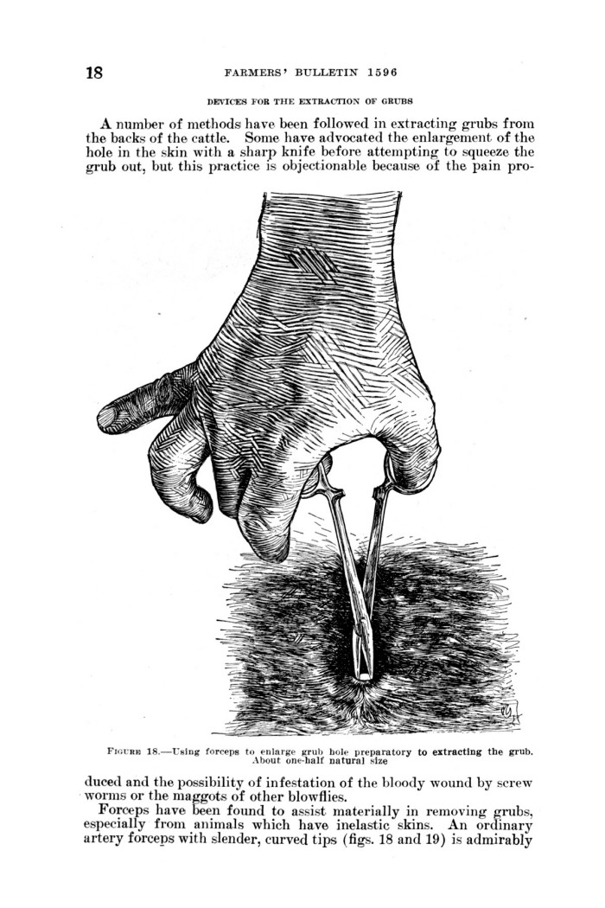

Bishopp, F. C. (Fred Corry), 1884-1970.; Laake, E. W. (Ernest William), 1887-1986. & Wells, R. W. (Roscoe Ward), b. 1890. Cattle grubs or heel flies with suggestions for their control. Washington D.C. UNT Digital Library. <http://digital.library.unt.edu/ark:/67531/metadc1750/>. Accessed 11 April 2016.

**Figure 2.10** Tool developed to manually remove cattle grubs.

### 

### 2.8.2 Dipping Vats

In the early 1900’s, experiments by the Bureau of Entomology used dipping vats (Figure 2.12) that contained an arsenic solution or a 2% coal-tar creosote solution (Bishopp et al., 1926). In the experiments, the solution was placed in the vats to a depth of about 20 cm and the cattle were moved through the vat at 4-day intervals (Bishopp et al., 1926). The theory was based on the fact that a large number of the eggs of the heel fly were deposited on the legs of the animal and knowing that the incubation time was three or four days, either the eggs or the grubs were going to be destroyed (Bishopp et al., 1926). Producers realized that some of the eggs were deposited in locations not reached by the solution and eggs were not being killed (Bishopp et al., 1944). The dipping structure was a concrete pool that had a drop in one side and a ramp on the other. Animals were herded through the dipping vat and allowed to swim to the ramp on the other side (McLaren et al., 1998). According to Ng (1999), each bath could contain about 2,800 gallons of solution.

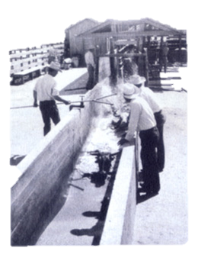

Bishopp, F. C. (Fred Corry), 1884-1970.; Laake, E. W. (Ernest William), 1887-1986. & Wells, R. W. (Roscoe Ward), b. 1890. Cattle grubs or heel flies with suggestions for their control. Washington D.C. UNT Digital Library. <http://digital.library.unt.edu/ark:/67531/metadc1750/>. Accessed 11 April 2016.

**Figure 2.11** Dipping vat used in the 1900’s containing arsenic solution or 2% coal-tar creosote solution.

# 

# **2.8.3 Rotenone**

Early chemicals to fight grubs were administered in powder form (Bishopp et al., 1944). One insecticidal compound was rotenone, which was also known by the trade names of “Derris”, “Prentox”, or “Tubatoxin”. The powder originated from finely ground roots of the jicama vine plant, which usually varied in amount from 2 to 6 percent; material containing 5 percent was recommended (Bishopp et al., 1944). Rotenone worked by interfering with the [electron-transport chain](https://en.wikipedia.org/wiki/Electron_transport_chain) in [mitochondria](https://en.wikipedia.org/wiki/Mitochondria). It inhibited the transfer of electrons from iron-sulfur centers in [complex I](https://en.wikipedia.org/wiki/Complex_I) to [ubiquinone](https://en.wikipedia.org/wiki/Ubiquinone). This interfered with [NADH](https://en.wikipedia.org/wiki/Nicotinamide_adenine_dinucleotide) during the creation of usable cellular energy ([ATP](https://en.wikipedia.org/wiki/Adenosine_triphosphate)). Complex I was unable to pass its electron to [CoQ](https://en.wikipedia.org/wiki/CoQ), creating a back-up of electrons within the mitochondrial matrix. Cellular oxygen was reduced, creating a [reactive oxygen species](https://en.wikipedia.org/wiki/Reactive_oxygen_species), which damaged [DNA](https://en.wikipedia.org/wiki/DNA) and other components of the mitochondria (Mehta and Li, 2009). During the early 1900’s this was the most satisfactory substance to kill grubs. The mixture of the powder consisted of one-part derris (of which 5% was rotenone) and two parts of carrier such as pyrophyllite or frianite (McKay, 1952). Historical reports (USDA, 1943) suggested that treatments using rotenone powder and pyrophyllite or frianite were more effective than those made by adding sulfur because they were able to penetrate the hair better and also because double the number of animals could be treated with the same amount of derris. When a shaker can was used to apply the powder, an average application of 2-3 ounces of mixture was required to be sufficient to treat an animal. The mixture would penetrate the hair coat and enter the body through the holes made by the grubs (USDA, 1943). The downfall to this type of application was that the effectiveness of the treatment depended on quantity and size of grub holes. In the 1950’s, rotenone was the only toxicant recommended for control of cattle grubs and no benefits were to be expected until the year after treatment (McKay, 1952). During this era, power spraying rotenone became popular. This was the most rapid method of applying the treatment to cattle, and was recommended for larger herds. The treatment used 7.5 to 10 pounds of cube or derris powder containing 5% rotenone, which was added to 100 gallons of water. No matter what method of applying rotenone was used, the most effective time for application was 30 days after the appearance of the first grubs in the back, and thereafter at 30- to 45-day intervals throughout the grub season. Rotenone was a very toxic chemical and potential poisoning concerns existed because drainage could potentially reach water sources (McKay, 1952).

### 2.8.4 Organophosphates

Organophosphates became popular in the 1960’s. Organophosphorus insecticides inhibit acetylcholinesterase (AchE), an enzyme that hydrolyzes acetylcholine (Ach) in the nervous system of animals. Ach is involved in the transmission of signals from nerves to muscles and between neurons in the brain. The role of AchE is to terminate the transmission of nervous signals where Ach is the neurotransmitter. By inhibiting the activity of AchE, organophosphates prevent the termination of those nervous signals. Subsequently, parasites are paralyzed and die quickly (Bajgar, 2004).

In 1956, two compounds were introduced for testing as systemic organophosphorus insecticides to fight grubs, O-dimethyl O-(2, 4, 5-trichlorophenyl) phosphorothioate (Ronnel), which was administered as a bolus (about 15 grams), or a drench (The Steamboat Pilot, 1957), and O, O-diethyl O-(3-chloro4-methyl-7-coumarinyl) phosphorothioate (Coumaphos)applied as a spray (Rich et al., 1961). In 1958, both compounds were registered for distribution in the U.S. and Canada. Ronnel was also known as DowET-57 (The Steamboat Pilot, 1957) and was marketed under the trade names of Trolene FM and Rid-Ezy. Coumaphos was known as Bayer 21/199 and marketed under the trade name of Co-Ral (Rich et al., 1961). Trolene was incorporated into a ground sorghum-grain premix and was fed in the complete ration; it was suggested that the premix be incorporated into daily rations for 7-14 days to effectively control grubs in feedlot cattle (Fink and Riley, 1975). Trolene FM destroyed both young and mature grubs. It was advisable to not treat sick animals with the mixture, and ensuring that cattle had access to water before and after the feeding period was essential (Cooperative Extension Service, 1965).

Co-Ral treatment was available in three application methods, spray, pour-on, and dipping vat solution. In spray form, 12 pounds of Co-Ral 25% was mixed in 100 gallons of water and sprayed on animals; cattle that were sick or animals less than three months of age were not treated. Applying Co-Ral via pour-on was a ready-to-use formulation and administered along the back of cattle, applying one-half fluid ounce per 100 pounds of body weight. The dipping vat solution was effective. This method was formulated like the spray method, adding 8 pounds of Co-Ral 25% to each 100 gallons of water. Dipping over-heated animals was not recommended.

### 2.8.4.1 Ruelene

In 1960, crumofate was first applied to cattle in southern California (Riehl et al., 1965). It was also known under the trade name of “Ruelene”(4-tert-butyl-2-chlorophenyl methyl methylphos-phoramidate). Two methods of Ruelene were used, spray and pour-on (Rogoff et al., 1960). When spraying, two gallons of Ruelene were added to 100 gallons of water, and the resulting solution was applied with a high-pressure sprayer, wetting the skin on the backs of cattle. Mixed Ruelene solution was applied at a rate of 1 gallon per 300 pounds of body weight (Cooperative Extension Service, 1965). When applying Ruelene as a pour-on, one-half gallon of Ruelene was diluted with one gallon of water; one fluid ounce of the mixture per 100 pounds of body weight was poured along the back of the animal. It was important to not treat animals that were sick or under stress and Ruelene was not to be applied during extremely hot and humid weather because of possible skin blistering (Cooperative Extension Service, 1965). Ruelene was labeled with a 28-day withdrawal period before slaughter (Cooperative Extension Service, 1965).

### 2.8.4.2 Warbex

The topical use of famphur (O, O-dimethyl O-[p-(dimethylsulfamoyl) phenyl] phosphorothioate) (Henry et al., 1985), also known under the trade name of “Warbex” was tested in the 1960’s. The solution was administered to livestock as a pour-on, feed additive, or by intramuscular injection (Ivey et al., 1976). The efficacy of famphur formulations applied to animals as a pour-on and as a high-concentrate, low-volume intramuscular injection for control of cattle grubs was shown from tests in the 1960's (Drummond, 1964; Kohler & Rogoff, 1962; Marquardt & Hawkins, 1962). In later tests, effective and safe dosages were reported to range from 40 to 55 mg/kg for the pour-on and 7 to 25 mg/kg for the intramuscular injection (Drummond, 1963). It was not until 1968 that the famphur pour-on formulation was registered for commercial use. During subsequent years, numerous animal systemic insecticides became available in different grubicide formulations for use as sprays, dips, feed additives, mineral supplements, pour-ons, and spot-ons (Loomis et al., 1978).

Similar to famphur, fenthion (O, O dimethyl O-[4-methylthio)-m-tolyl] phosphorothioate), known under the trade names of “Tiguvon” and “Spotton” came onto the market. Formulations were developed for pour-on ready-for-use applications that were well tolerated by the skin (Stendel, 1977). The mixture was used at the rate of one-half fluid ounce per 100 pounds of body weight placed on the backline of the animal. Only one application per season was made for initial grub control. A second application was made if animals became re-infested and as soon as possible after heel-fly activity ceased. Cattle were not to be slaughtered within 35 days following a single treatment. If a second application was made for grub control, cattle were not to be slaughtered within 45 days of the second treatment. With the pour-on technique, a relatively large amount of the formulation was necessary for treatment of animals. This caused difficulties, which led to development of spot-on formulations. In the formulations, the active ingredient was very concentrated and was absorbed quickly. In comparison with the pour-on method, the insecticide was applied to a relatively small spot on the skin (Stendel, 1977).

### 2.8.5 Avermectins

A group of anthelmentics were discovered from an actinomycete isolated by Kitasato Institute from a soil sample collected at a golf course at Kawana, Ito City, Shizuoka Prefecture, Japan (Burg, 1979). The actinomycete isolate was sent to Merck Sharp & Dohme Research Laboratories for testing and evaluation. Early tests indicated that whole broth was active against *Nematospiroides dubius* in mice. The anthelmintic activity was isolated and identified as a family of closely related compounds. The complex, which was named avermectin, is very active against a variety of nematodes (Burg, 1979).

The discovery of avermectins in the late 1970’s changed the efficiency of how cattle grubs were treated (Burg et al., 1979). Avermectins are naturally occurring compounds produced by fermentation of the soil-dwelling actinomycete *Streptomyces avermitilis*. The first to be developed and tested for efficacy against cattle grubs and other parasites of cattle was ivermectin (Campbel et al., 1983; Leaning, 1984; Preston, 1984). Ivermectin, a semi-synthetic derivative of avermectin B1, consists of an 80:20 mixture of equipotent homologues, 22, 23-dihydro Bla and 22, 23-dihydro B1b (Goidie et al., 1993). Introduced under the trade name “Ivomec” into the market in the early 1980’s, it has been used extensively for treatment of endo and ectoparasites of livestock and companion animals (Campbell and Benz, 1984; Campbell, 1985). By the early 1980’s, this anthelmintic compound was believed to be one of the most effective insecticides ever developed for systemic use against cattle grubs (Khan et al., 1983).

Ivermectin binds with high affinity to glutamate-gated chloride channels in invertebrate nerve and muscle cells, causing an increase in permeability of the cell membrane to chloride ions with hyperpolarization of the nerve or muscle cell. Hyperpolarization results in paralysis and death of the parasite (Wolstenholme and Rogers, 2005). Today, three similar compounds exist -- ivermectin, doramectin, and eprinomectin. The potency and broad-spectrum activity of ivermectin against endoparasites and ectoparasites of cattle, sheep, swine, dogs, and horses is well documented (Drummond, 1985; Lasota and Dybas, 1991). Moreover, introduction of ivermectin as a veterinary parasiticide in France in 1981 revolutionized animal anti-parasitic chemotherapy (McKellar and Benchaoui, 1996). Within a period of 5 years, ivermectin had captured 16% of the worldwide anti-parasitic sales (Bloomfield, 1988), and by 1990 it was estimated that more than 800 million cattle had been treated with ivermectin (Sutherland, 1989). Despite concerns about possible environmental consequences from its use (Wall and Strong, 1987), ivermectin has unique characteristics not found in organophosphorus systemics. The first is ability to kill migrating larvae, but unlike systemics, it is also highly efficacious against second-and third-instar larvae in warbles (Kahn et al., 1985). The latter activity permits use of the material as a late-season (Scholl et al., 1984) or pour-on (Alva-Valdes et al., 1986) treatment for grub-infested cattle that is not possible with traditional systemic insecticides, which are ineffective once the larvae are inside their warbles. Additionally, ivermectin at low doses kills 100% of migrating *Hypoderma* larvae of both species (Drummond, 1985). However, because it is used against a wide range of internal and external parasites, the lowest effective dilutions could lead to problems of resistance and reduced efficacy against other targeted species (Leaning, 1984).

Doramectin was first commercialized in 1993 in Brazil and South Africa and has been the subject of extensive worldwide anti-parasitic research. The compound is known under the trade name of “*Dectomax”* (Vercruysse et al., 1993). It is effective as an injectable formulation against cattle mites, cattle lice, and cattle grubs (Hendrickx et al., 1993; Logan et al., 1993). The recommended dosage is 200 µg/kg (Vercruysse et al., 1993).

Eprinomectin is the most recently commercialized avermectin in large animals and was developed in the 1990’s as a topical treatment for use against endo- and ectoparasites in cattle of all classes and ages (Shoop et al., 1996; Shoop and Soll, 2002). Today, eprinomectin is known under the trade name of “*Eprinex”* (Rehbein, 2012).

### 2.8.6 Milbemycins

Milbemycins were discovered in 1973 and were developed for crop protection (Takiguchi et al., 1980). They worked as insecticidal compounds for crop protection by Sankyo scientists (Shoop et al., 1995). Despite predating the discovery of ivermectin, they were not used in veterinary practice until the mid-1980’s. Milbemycins are similar avermectins in mode of action. They open [glutamate](https://en.wikipedia.org/wiki/Glutamate)-sensitive [chloride channels](https://en.wikipedia.org/wiki/Chloride_channel) in [neurons](https://en.wikipedia.org/wiki/Neuron) and [myocytes](https://en.wikipedia.org/wiki/Myocyte) of [invertebrates](https://en.wikipedia.org/wiki/Invertebrate), leading to [hyperpolarization](https://en.wikipedia.org/wiki/Hyperpolarization_%28biology%29) of the cells and blocking of signal transfer (Martin, 1997). Hyperpolarization results in paralysis and death of the parasite (Wolstenholme and Rogers, 2005). Moxidectin is a milbemycin first marketed in Argentina in 1990. It was commercialized worldwide for use as an injectable in cattle (McKellar and Benchaoui, 1996).

# **2.9 Immune response and vaccination**

Generally, fewer *Hypoderma spp*. larvae appear in the back of older cattle than in calves or yearlings (Bishopp et al., 1944), which suggests development of immunity with increased age. Major advances have occurred in the study of *Hypoderma* digestive enzymes and of the bovine-immune response to infestation by cattle grubs. Initial investigations using extracts of *Hypoderma* spp. larvae as candidate vaccines (Baron and Weintruab, 1986; Kahn et al., 1960; Pruett and Barret, 1985) led to concerted attempts toward the development of a defined vaccine against infestation by cattle grubs. The advantages of a vaccine over chemical control are abundant: less damage to the environment, complete and lifetime conversion of susceptible animals to resistant status, and use in animals such as dairy cattle for which application of systemic insecticide is prohibited during lactation (Scholl, 1993). Experimental vaccines have not, to date, killed more migrating larvae and protected the subcutaneous tissues of the back or prevented hide damage in individual animals (Scholl, 1993). However, because of increased mortality of larvae arriving at the back, current experimental vaccines are designed to kill more larvae and therefore reduce abundance of *Hypoderma* spp. (Scholl, 1993). Thus, experimental vaccines already developed might have limited value for use in intensive programs to drastically reduce abundance of cattle grubs during a short period of time (Chabaudie et al., 1991). Vaccines might, on the other hand, be useful in less-intensive control programs and as a complement instead of a substitute for chemical control in integrated pest management programs (Scholl, 1993).

# **2.10 BIBLIOGRAPHY**

Aiello, S. E., and Mays A., "Cattle Grubs." *The Merck Veterinary Manual*. 8th ed. Whitehouse Station, NJ: Merck &, in Cooperation with Merial, (1998): 629-632.

Alva-Valdes, R., Wallace, D. H., Holste, J. E., Egerton, J. R., Cox, J. L., Wooden, J. W., and Barrick, R. A. "Efficacy of ivermectin in a topical formulation against induced gastrointestinal and pulmonary nematode infections, and naturally acquired grubs and lice in cattle." *American Journal of Veterinary Research* 47.11 (1986): 2389-2392.

Amer, A. and Mehlhorn, H. "The sensilla of Aedes and Anopheles mosquitoes and their importance in repellency." *Parasitology research* 99.4 (2006): 491-499.

Andrews, A. H. "Warble Fly: The Life Cycle, Distribution, Economic Losses and Control." *Veterinary Record* 14 (1978): 348-353.

Bajgar, J. "Organophosphates/nerve agent poisoning: mechanism of action, diagnosis, prophylaxis, and treatment." *Adv Clin Chem* 38.1 (2004): 151-216.

Baron, R. W., and Weintruab J., "Immunization of cattle against hypodermatosis (Hypoderma lineatum (Devill.) and H. bovis (L.)) using H. lineatum antigens." *Veterinary parasitology* 21.1 (1986): 43-50.

Batte, E. G. "Differential diagnosis of parasitic dermatitis of cattle." *Journal of the American Veterinary Medical Association* 161.11 (1972): 1265-1268.

Beesley, W. N. "Economics and progress of warble fly eradication in Britain." *Veterinary medical review* (1974): 334-347.

Beesley, W. N. "Observations on the development of *Hypoderma lineatum* de Villiers (Diptera, Oestridae) in the bovine host." *Ann. Trop. Med. Parasit.* 55.1 (1961): 18-24.

Bishopp, F. C., 1884-1970.; Laake, E. W., 1887-1986. & Wells, R. W., b. 1890. Cattle grubs or heel flies with suggestions for their control.. Washington D.C.. UNT Digital Library.http://digital.library.unt.edu/ ark:/67531/metadc1750/. Accessed 30 March 2016.

Bishopp, F. C., Laake, E. W., Burndrett, H. M., and Wells, R. W. "The cattle grubs or ox warbles, their biologies and suggestions for control." *United States Department of Agriculture* Bull. 1369 (1926).

Bishopp, F. C., Laake, E. W., and Wells, R. W. "Cattle Grubs or Heel Flies with Suggestions for their Control." *Farmers' Bulletin. US Department of Agriculture* 1596 (1944).

Bloomfield, G., “Endoparasites” The Veterinary Market. PJB Publications, Richmond, UK. (1988): 59-60.

Bromley, A. K., Dunn J. A. and Anderson, M. "Ultrastructure of the antennal sensilla of aphids." *Cell and tissue research* 205.3 (1980): 493-511.

Burg, R. W., Miller, B. M., Baker, E. E., Birnbaum, J., Currie, S. A., Hartman, R., Kong, Y. L., Monaghan, R. L., Olson, G., Putter, I, Tunac, J. B., Wallick, H., Stapley, E. O., Oiwa, R., and Ōmura, S., "Avermectins, new family of potent anthelmintic agents: producing organism and fermentation." *Antimicrobial Agents and Chemotherapy* 15.3 (1979): 361-367.

Campbell, J. B., Roselle, R. E., and White, G., "EC71-1528 Cattle Grub Control in Nebraska." (1971).

Campbell, W. C. "Ivermectin: an update." *Parasitology today* 1.1 (1985): 10-16.

Campbell, W. C. and Benz G. W., "Ivermectin: a review of efficacy and safety." *Journal of Veterinary Pharmacology and Therapeutics* 7.1 (1984): 1-16.

Campbell, W. C., Fisher, M. H., Stapley, E. O., Albers-Schonberg, G., and Jacob, T. A., "Ivermectin: a potent new antiparasitic agent." *Science* 221.4613 (1983): 823-828.

Carpenter, G. H. and Hewitt T. R., "The Reproductive Organs and the Newly Hatched Larva of the Warble-fly (Hypoderma)." Royal Dublin Society, 1914.

Chabaudie, N., Villejoubert, C. and Boulard, C.,"The response of cattle vaccinated with hypodermin A to a natural infestation of Hypoderma bovis and Hypoderma lineatum." *International Journal for Parasitology* 21.7 (1991): 859-862.

Colwell, D. D., Hall, M. J., and Scholl, P. J., eds. *The oestrid flies: biology, host-parasite relationships, impact and management*. CABI. (2006).

de Freitas Fernandes, F., de Paula e Souza Freitas, E., Linardi, P.M. and Pimenta, P.F.P. "Ultrastructure of contact-chemoreceptor sensilla found among the genae of female Gasterophilus nasalis." *Journal of Parasitology* 91.5 (2005): 1218-1220.

Drummond, R. O. "Economic aspects of ectoparasites of cattle in North America." *23. World Veterinary Congress, Montreal (Canada), 19 Ago 1987*. Veterinary Learning Systems, (1987): 9-24.

Drummond, R. O., “Effectiveness of Ivermectin for Control of Arthropod Pests of Livestock.” *Supplement to the Southwestern Entomologist (USA)*. (1985).

Drummond, R. O. "Further evaluation of animal systemic insecticides, 1962." *Journal of Economic Entomology* 56.6 (1963): 831-834.

Drummond, R. O. "Further evaluation of animal systemic insecticides, 1963." *Journal of Economic Entomology* 57.5 (1964): 741-745.

Everett, A.L., Miller, R.W., Gladney, W.J. and Hannigan, M.V., "Effects of some important ectoparasites on the grain quality of cattlehide leather." *Journal of the American Leather Chemists Association* (1977).

Fink, G., and Riley, J. G., "Efficacy of Trolene 40 insecticidal premix to control grubs in feedlot cattle." Proc. of Cattlemen's Day, Kansas State University, Manhattan, KS., Kansas State U. Agricultural Experiment Station, (1976): 62-63.

French, F. E., Raun, E. S., and Herrick, J. B. "Trolene and Dowco 109 as feed additive for grub control. Iowa State Col." *J. Sci* 33 (1958): 119.

Gingrich, Richard E. "Acquired resistance to Hypoderma lineatum: comparative immune response of resistant and susceptible cattle." *Veterinary parasitology* 9.3 (1982): 253-260.

Gojmerac, W. L. "Pest Control on Cattle." *Department of Agricultural Journalism, University of Wisconsin-Madison* A2212 (1987).

Gooding, R. H., and Weintraub, J., "The genitalia of Hypoderma bovis (L.) and H. lineatum (de Vill.)(Diptera: Oestridae)." *Canadian Journal of Zoology* 38.3 (1960): 565-574.

Goudie, A. C., Evans, N. A., Gration, K. A. F., Bishop, B. F., Gibson, S. P., Holdom, K. S., Kaye, B., Wicks, S. R., Lewis, D., Weatherley, A. J. and Bruce, C. I., "Doramectin—a potent novel endectocide." *Veterinary Parasitology* 49.1 (1993): 5-15.

Guha, L., Seenivasagan, T., Bandyopadhyay, P., Iqbal, S.T., Sathe, M., Sharma, P., Parashar, B. D. and Kaushik, M. P. "Oviposition and flight orientation response of Aedes aegypti to certain aromatic aryl hydrazono esters." *Parasitology research* 111.3 (2012): 975-982.

Hadwen. S., “The economic aspect of warble flies.” Can. Dept. Agric. Health/Anim. Branch Bull. 16. (1912): 20.

Hadwen, S., "Warble Flies, Hypoderma lineatum Villers, and Hypoderma bovis De Geer." *Warble Flies, Hypoderma lineatum Villers, and Hypoderma bovis De Geer* (1919): 24.

Hadwen, S. and Bruce E. A., "Observations on the Migration of Warble Larvae through the Tissues." *Health Animals Branch, Scient. Ser. Bull.* 22 (1916).

Hendrickx, M.O., Anderson, L., Boulard, C., Smith, D.G. and Weatherley, A.J., “Efficacy of doramectin against warble fly (Hypoderma bovis).” Veterinary Parasitology. 49: (1993): 75-84.

Henny, C. J., Blus, L. J., Kolbe, E. J., and Fitzner, R. E.. “Organophosphate Insecticide (Famphur) Topically Applied to Cattle Kills Magpies and Hawks.” *The Journal of Wildlife Management* (1985): 648–658.

Hoelscher, C. E., Patrick, C. D., and Robinson, J. V., "Managing external parasites of Texas livestock and poultry." (2000).

Hunter, F. F., and Adserballe C. F. "Cuticular structures on the antennae of Hypoderma bovis De Geer (Diptera: Oestridae) females." *International Journal of Insect Morphology and Embryology* 25.1 (1996): 173-181.

Ismail, I. A. "Comparative Study of Sense Organs in the Antennae of Culicine and Anopheline Female Mosquitoes." *Acta tropica* 21 (1964): 155.

Ivey, M. C., Palmer, J. S., and Washburn, R. H., "Famphur and Its Oxygen Analogue: Residues in the Body Tissues of Reindeer." *Journal of Economic Entomology* 69.2 (1976): 260-262.

Jobling, B. "The structure of the head and mouth-parts in the Nycteribiidae (Diptera Pupipara). " *Parasitology* 20.03 (1928): 254-272.

Kaufman, P. E., and Weeks E. N. I., "Cattle Grub Management." ENY-290 Entomology and Nematology Department, UF/IFAS Extension. Mar. (2013): 1-6.

Khan, M. A. "Some factors involved in systemic insecticide toxicosis: esophageal lesions in heifers treated with coumaphos, crufomate and trichlorfon." *Canadian Journal of Animal Science* 51.2 (1971): 411-417.

Khan, M.A., Connell, R. and Darcel, C.L.Q., "Immunization and Parenteral Chemotherapy for the Control of Cattle Grubs Hypoderma Lineatum." *Canadian journal of comparative medicine and veterinary science* 24.6 (1960): 177-180.

Khan, M. A., Hironaka, R., Schaalje, G. B., Effectiveness of Ivomec for systemic control of warble grubs. In Research Highlights-l982, Lethbridge, Alta.: Agric. Can. Res. Stn. (1983): 42-45.

Khan, M. A., Scholl, P. J., Weintraub, J., “Ivomec for control of hypodermal larvae.” In Pesticide Research Report-l 984. Ottawa, Can­ada: Expert Comm. Pest. Use Agric. (1985): 193

Kohler, P. H., and Rogoff, W. M.. "Control of cattle grubs by pour-on, injection, and spray." *Journal of Economic Entomology* 55.4 (1962): 539-544.

Lasota, J. A., and Dybas R. A., "Avermectins, a novel class of compounds: implications for use in arthropod pest control." *Annual review of entomology* 36.1 (1991): 91-117.

Leaning, W. H. "Ivermectin as an antiparasitic agent in cattle." *Modern veterinary practice* 65.9 (1984): 669-672.

Logan, N.B., Weatherley, A.J., Phillips, F.E., Wilkins, C.P. and Shanks, D.J., "Spectrum of activity of doramectin against cattle mites and lice." *Veterinary parasitology* 49.1 (1993): 67-73.

Loomis, E. C., and Schock R. C., "Comparison of Famphur (Warbex®) Pour-On and Intramuscular Injectable Formulations for Cattle Grub Control, California, 1975–1976." *Journal of medical entomology* 14.6 (1978): 649-651.

Marquardt, W.C. and Hawkins Jr, W.W., "Control of cattle grubs by the intramuscular injection of Bayer 29493 or CL 38023." *The Cornell veterinarian* 52 (1962): 228-236.

Martin, R. J. "Modes of action of anthelmintic drugs." *The Veterinary Journal* 154.1 (1997): 11-34.

McIver, S. B. "Structure of cuticular mechanoreceptors of arthropods." *Annual review of entomology* 20.1 (1975): 381-397.

McKay, K. "Cattle grub control: Rotenone applied during larvae stage of heel fly most effective." *California Agriculture* 6.10 (1952): 13.

McKellar, Q.A. and Benchaoui, H.A., "Avermectins and milbemycins." *Journal of veterinary pharmacology and therapeutics* 19.5 (1996): 331-351.

McLaren, R.G., Naidu, R., Smith, J. and Tiller, K.G., "Fractionation and distribution of arsenic in soils contaminated by cattle dip." *Journal of Environmental Quality* 27.2 (1998): 348-354.

Mehta, S.L. and Li, P.A. "Neuroprotective role of mitochondrial uncoupling protein 2 in cerebral stroke." *Journal of Cerebral Blood Flow & Metabolism* 29.6 (2009): 1069-1078.

Ng, J. C. "Speciation, bioavailability and toxicology of arsenic in the environment.” Pd.D. Dissertation, University of Australia, Queensland, Australia (1999).

Panadero, R., López, C., Mezo, M., Morrondo, P. and Díez-Baños, P., "Effect of early treatment with ivermectin and doramectin on the dynamics of antibody response in cattle naturally infested by Hypoderma lineatum and H. bovis." *Veterinary parasitology* 73.3 (1997): 325-334.

Papavero, N. *The world Oestridae (Diptera), mammals and continental drift*. Vol. 14. Springer Science & Business Media, (2012).

Preston, J. M. "avermectins: new molecules for use in warble fly control." *Warble fly control in Europe: a symposium in the EC Programme of Coordination of Research on Animal Pathology, Brussels, 16-17 September 1982/edited by Chantal Boulard, H. Thornberry*. Rotterdam: AA Balkema (1984).

Pruett, J.H. and Barrett, C.C., "Kinetics development of humoral anti-Hypoderma lineatum antibody activity in the serum of vaccinated and infested cattle." *The Southwestern entomologist* (1985).

Rehbein, S., Visser, M., Kellermann, M. and Letendre, L., "Reevaluation of efficacy against nematode parasites and pharmacokinetics of topical eprinomectin in cattle." *Parasitology research* 111.3 (2012): 1343-1347.

Rich, G.B. and Ireland, H.R., "An Appraisal Of Ruelene And Trolene Against Cattle Grub Infestations, (Oestridae: Diptera)." *Canadian Journal of Animal Science* 41.1 (1961): 115-119.

Riehl, L., Addis, D., Burgess, J. and Deal, A., "Pour-on applications of Ruelene For cattle grub control." California Agriculture 19.9 (1965): 5.

Rogoff, W.M. and Kohler, P.H., "Effectiveness of Ruelene applied as localized “pour-on” and as spray for cattle grub control." Journal of Economic Entomology 53.5 (1960): 814-817.

Ross, K. T. A. "Comparative study of the antennal sensilla of five species of root maggots: Delia radicum L., D. floralis F., D. antiqua Mg., D. platura Mg.(Diptera: Anthomyiidae) and Psila rosae F.(Diptera: Psilidae)." *International Journal of Insect Morphology and Embryology* 21.2 (1992): 175-197.

Ross, K. T. A., and Anderson, M. "Morphology of the antennal sensilla of the cabbage root fly, Delia radicum L. (Diptera: Anthomyiidae)." *International Journal of Insect Morphology and Embryology* 16.5 (1987): 331-342.

Scharff, D. K., Sharman, G. A. and Ludwig, P., "Illness and death in calves induced by treatments with systemic insecticides for the control of cattle grubs." *Journal of the American Medical Association* 141 (1962): 582-587.

Scholl, Philip J. "Biology and control of cattle grubs." Annu. Rev. Entomol. 39 (1993): 53-70.

Scholl, P.J., Weintraub, J. and Khan, M.A., "Late season treatment of cattle for control of warble grubs." *Res. Highlights* 1984 (1984): 29-30.

Seenivasagan, T., Sharma K. R., and Prakash, S. "Electroantennogram, flight orientation and oviposition responses of Anopheles stephensi and Aedes aegypti to a fatty acid ester-propyl octadecanoate." *Acta tropica* 124.1 (2012): 54-61.

Shanbhag, S. R., Singh, K. and Singh, R. N. "Fine structure and primary sensory projections of sensilla located in the sacculus of the antenna of Drosophila melanogaster." *Cell and tissue research* 282.2 (1995): 237-249.

Shoop, W.L., Egerton, J.R., Eary, C.H., Haines, H.W., Michael, B.F., Mrozik, H., Eskola, P., Fisher, M.H., Slayton, L., Ostlind, D.A. and Skelly, B.J., "Eprinomectin: a novel avermectin for use as a topical endectocide for cattle." *International journal for parasitology* 26.11 (1996): 1237-1242.

Shoop, W.L., Mrozik, H. and Fisher, M.H., "Structure and activity of avermectins and milbemycins in animal health." *Veterinary parasitology* 59.2 (1995): 139-156.

Shoop, W., and Soll, M. "Ivermectin, abamectin and eprinomectin." *Macrocyclic Lactones in Antiparasitic Therapy*. CABI Publishing Oxon, UK, (2002): 1-29.

Simmons, S. W. "Some Histopathological Changes in the Skin of Cattle infested with Larvae of Hypoderma lineatum." *Journal of the American Veterinary Medical Association* 95.750 (1939): 283-288.

Smallegange, R. C., Kelling, F. J. and Otter, C. J. D. "Types and numbers of sensilla on antennae and maxillary palps of small and large houseflies, Musca domestica (Diptera, Muscidae)." *Microscopy research and technique* 71.12 (2008): 880-886.

Stendel, W. "Control of cattle grubs with fenthion pour-on and trichlorfon spot-on in Germany." *Veterinary Parasitology* 3.3 (1977): 245-249.

Sukontason, K., Sukontason, K.L., Piangjai, S., Boonchu, N., Chaiwong, T., Ngern-klun, R., Sripakdee, D., Vogtsberger, R.C. and Olson, J.K. "Antennal sensilla of some forensically important flies in families Calliphoridae, Sarcophagidae and Muscidae." *Micron* 35.8 (2004): 671-679.

Sutherland, I. H. "Veterinary use of ivermectin." *Acta Leidensia* 59.1-2 (1989): 211-216.

Takiguchi, Y., Mishima, H., Okuda, M., Terao, M., Aoki, A. and Fukuda, R., "Milbemycins, a new family of macrolide antibiotics: Fermentation, isolation and physicochemical properties." *The Journal of antibiotics* 33.10 (1980): 1120-1127.

Vercruysse, J., Dorny, P., Hong, C., Harris, T.J., Hammet, N.C., Smith, D.G. and Weatherley, A.J., "Efficacy of doramectin in the prevention of gastrointestinal nematode infections in grazing cattle." *Veterinary Parasitology* 49.1 (1993): 51-59.

Wall, R., and Strong, L., "Environmental consequences of treating cattle with the antiparasitic drug ivermectin." *Nature* 327.6121 (1987): 418-421.

Wang, Q. K., Yang, Y.Z., Liu, M.Q. and Zhang, D. "Fine structure of Delia platura (Meigen)(Diptera: Anthomyiidae) revealed by scanning electron microscopy." *Microscopy research and technique* 77.8 (2014): 619-630.

Wolstenholme, A.J. and Rogers, A.T. "Glutamate-gated chloride channels and the mode of action of the avermectin/milbemycin anthelmintics." *Parasitology* 131.S1 (2005): S85-S95.

Zhang, Dong, Wang, Q.K., Hu, D.F. and Li, K., "Cuticular structures on antennae of the bot fly, Portschinskia magnifica (Diptera: Oestridae)." *Parasitology research* 111.4 (2012): 1651-1659.

Zumpt, F. "Myiasis in Man and Animals in the Old World. A Textbook for Physicians, Veterinarians and Zoologists." *Myiasis in Man and Animals in the Old World. A Textbook for Physicians, Veterinarians and Zoologists.* (1965).

"Get Rid of Cattle Grubs in Beef Cattle." *Cooperative Extension Service-New Mexico State University* (1965).

"New Chemical Released for Grub Control." *The Steamboat Pilot* [Steamboat Springs, CO.] 28 Nov. 1957, 20th ed.: 9.

"Rotenone Reduced in Dusts for Cattle Grub Treatments." *United States Department of Agriculture-Agricultural Research Administration Bureau of Entomology and Plant Quarantine and Bureau of Animal Industry* (1943).

http://www.clemson.edu/extension/pest_ed/history/l.html

Trade Practices for Proper Packer Cattlehide Delivery." *Http://www.ushsla.org*. Leather Industries of America and U.S. Hide and Leather Association, n.d. Web. 16 Apr. 2016.

**CASE STUDY: IMPACT OF *HYPODERMA LINEATUM* UPON LIVE GROWTH, CARCASS ATTRIBUTES, AND HIDE VALUE OF FED BEEF CATTLE**

# **CHAPTER III**

## 3.1 ABSTRACT

A case study was done at the WTAMU Research Feedlot from 14 November 2014 to 5 August 2015. While processing crossbred bulls (n=32), several cattle were identified to be infested with grubs, later identified as the common cattle grub, *Hypoderma lineatum* (Villers). Metaphylaxis was administered upon arrival (d 0). Cattle were vaccinated, dewormed, and individually identified. Cattle were placed on a starter ration (d0) and transitioned to a finishing ration (d45). Twelve days after arrival, all cattle were re-weighed and palpated to quantify infestation by cattle grubs; a hide map was used to record location of individual grubs. Grubs were manually extracted from the left side while grubs in the right side remained in the animals. Also, on d12, animals were administered a growth-promoting implant and band-castrated. Two grub-infested cattle were euthanized (d18) and examined to quantify damage in the hide and carcass. Hides were fleshed and converted into rawhide to document hide damage in the feeder calves. Grub samples were sent to Texas A&M Veterinary Medical Diagnostic Lab (TVMDL), College Station, Texas (d24); results concluded that the grubs were *Hypoderma lineatum* (d33). Two animals (grub-free) died from bovine respiratory disease during the study (d15, d50). The remaining cattle were reweighed (d12, d40, d70, d96, d124, d152, d180, d208, d234, d236, d264) to assess potential differences in growth rate. Cattle were slaughtered in two groups (n=9 on d234; n=19 on d264) at Tyson Fresh Meats, Amarillo, TX. Data collected during slaughter and grading processes included individual animal identification, liver score, hot carcass weight, longissimus muscle area, 12th rib subcutaneous fat depth, kidney-pelvic-heart fat, yield grade, marbling score, and quality grade. Hides were individually identified and tracked through the facility to hide processing. Hides were green de-fleshed, lime de-fleshed, and de-haired for 24 h; individual identity was maintained throughout. Hides were then exposed to blue-chroming chemicals for 24 h; next, blue-chrome hides were individually graded as #1, #2, or #3 hides. No difference in initial weight (*P* = 0.89), finished weight (*P* = 0.35), average daily gain (*P* = 0.59), hot carcass weight (*P* = 0.38), longissimus muscle area (*P* = 0.91), 12th rib subcutaneous fat depth (*P* = 0.64), yield grade (*P* = 0.84), or KPH fat (*P* = 0.38) was detected between grub-free and grub-infested cattle. Grub-infested cattle tended to have more marbling (*P* = 0.07) than did grub-free cattle. No difference in hide damage or value occurred between left sides (manually extracted) and right sides (grubs allowed to remain). Infestation by grubs did not negatively affect growth or carcass attributes. Hide damage in feeder calves resolved during the finishing period and grub-damaged hides met #1 criteria.

# 

## 3.2 INTRODUCTION

Cattle grubs, also called wolves or warbles are the larval or maggot stage of insects known as heel flies, warble flies, or gadflies (Bishopp et al., 1944). Larval stages of the flies are parasites of concern to cattle producers in North America because they cause damage that can decrease the value of the host (Drummond, 1987). Heel flies can reduce cattle comfort and impact daily growth, whereas grubs can damage the hide and lessen its value (Bishopp et al., 1944). Two species of cattle grubs are common to the U.S.; the most widespread is the common cattle grub, *Hypoderma lineatum* (Villers),present in every state; the other is the northern cattle grub, *Hypoderma bovis* (Linnaeus), which is predominant in the northern U.S. (Bishopp et al., 1944). Heel flies develop from grubs that have burrowed to and dropped from the backs of cattle. Common heel flies appear during the first warm days of spring and their activity increases as the season advances.(Scholl, 1993). Heel flies usually attach themselves low on the legs, particularly above the hoof. The flies locate close to the skin and deposit as many as 300 eggs, which are attached firmly to the hair of the animal. This is why the name “heel fly” has been used throughout time. Control of cattle grubs or heel flies has historically been one of the most important insect problems confronting the U.S. cattle industry (Bishopp et al., 1944). Economic losses are primarily attributable to the larvae that migrate through the host tissues and penetrate the skin, resulting in diminished hide value

(Andrews, 1978). Meat of cattle that are slaughtered while infested might also require extensive trimming, which will decrease carcass weight and thus value (Hendrickx et al., 1993).

The 1991 National Beef Quality Audit reported that 1.3% of the carcasses observed had visible grubs (Lorenzen et al. 1993) with a further decline to 0.03% in the subsequent audit in 1995 (Boleman et al, 1998). In the 2000, 2005, and 2011 National Beef Quality Audits no instances of visible grubs were recorded. In contrast, the Canadian Beef Quality Audit reported only 0.1% of carcasses with evidence of grubs in 1996 (Van Donkersgoed et al., 1997) with a further decline to 0.008% in the subsequent audit in 1998 (Van Donkersgoed et al., 2001).

The objective of this research was to determine if there was any significant difference in live growth, carcass attributes, and hide value between cattle with grubs and grub-free fed beef cattle.

## 3.3 Materials and methods

## 3.3.1 Initial discovery, cattle processing, and feeding

While processing crossbred bulls (n=32; Origin Producers Livestock Auction Company, San Angelo, TX) upon arrival, some animals in the load of cattle were identified to be infested with grubs whereas others were not affected. Cattle were dewormed with *fenbendazole* (SafeGuard;Merck Animal Health; Summit, NJ) and *doramectin* (Dectomax;Zoetis, Florham Park, NJ) upon arrival (d0) to treat internal parasites and the grubs. In addition, metaphylaxis was administered (*tulathromycin*; Draxxin; Zoetis; Florham Park, NJ), cattle were vaccinated for BVD/PI-3/BRSV (*Vista 5 SQ*; Merck Animal Health; Summit, NJ), and individually identified with a visual ear tag. Cattle were placed on a starter ration (d0) and later transitioned to a finishing ration (d45).

# **3.3.2 Manual removal, castration, and further processing**

Twelve days after arrival, all cattle were re-weighed and manually palpated to quantify infestation by grubs; a hide map was used to record location of the individual grubs. Grubs were manually extracted from the left side of infested animals to assess potential need for or benefit from physical removal; grubs on the right side remained in animals. Also on d12, animals were administered a growth-promoting implant (*200 mg trenbolone acetate and 40 mg estradiol*; Revalor® XS; Merck Animal Health) and castrated using restrictive surgical tube bands (The Callicrate Bander; St. Francis, KS). Grub samples on d24 were sent to Texas A&M Veterinary Medical Diagnostic Lab (TVMDL), College Station, Texas.

# **3.3.3 Meat laboratory harvest**

Two cattle (258, 343 kg) infested with grubs were randomly selected and slaughtered (d 18) at the West Texas A&M University Meat Laboratory to quantify carcass and hide losses in feeder calves. Cattle were immobilized using a captive bolt pistol, exsanguinated, and the hide was removed using a pneumatic de-hider. Esophageal surroundings were inspected for evidence of grubs or grub tracts. De-hided carcasses were evaluated for number of grubs observed in/on the subcutaneous fat (Figures 3.1, 3.2, 3.3). Carcasses were trimmed in locations where grubs were located. Grub samples collected from the carcasses were preserved in formaldehyde solution. Carcasses were eviscerated and split into halves, then the longissimus muscle was dissected and examined for grubs. After complete examination, both dismantled carcasses were disposed in a local landfill because those animals had not met withdrawal times for *Vista 5 SQ* (21d) or Dectomax (35d). Both hides were manually fleshed and converted into rawhide to document hide damage in the feeder calves (Figure 3.4).

**3.3.4 Live animal growth**

Two animals (grub free) died from bovine respiratory disease during the course of the study (d15, d50). The remaining cattle were periodically reweighed (d40, d70, d96, d124, d152, d180, d208, d234, d236, d264) to assess potential differences in growth rate.

**3.3.5 Commercial slaughter and hide processing**

Cattle were individually weighed before shipment for slaughter. Cattle were slaughtered in two groups (n=9 on d234; n=19 on d264) at Tyson Fresh Meats, Amarillo, TX. Data collected during the slaughter and grading processes included individual animal identification, liver score, hot carcass weight, longissimus muscle area, 12th rib subcutaneous fat depth, kidney-pelvic-heart fat, yield grade, marbling score, and quality grade (USDA, 1997). Hides were individually identified and tracked through the facility to hide processing. Hides were green de-fleshed, lime de-fleshed, and placed into containers where they underwent a de-hairing process for 24 hours. Hides were then placed into a different container for 24 hours where they underwent the chroming process to create wet blue chrome leather; after hides were removed from the container they were individually graded as #1, #2, or #3 hides according to industry standards (United States Hide, Skin & Leather Association).

**3.3.6 Statistical analysis**

The primary outcome variable of interest was the subjective ordinal hide-grade score. Secondary outcome variables were interval scale live animal growth and both interval and ordinal carcass grading outcomes. Because the case study was unbalanced (grub-infested=23; grub-free=5) and because the assumptions of ANOVA (Independence, normal distribution, and homogeneity of variances) were not met, the data were analyzed using non-parametric methods. The Mann-Whitney U test was chosen to analyze the data because they were represented as two independent samples. Median and quartile deviation for each variable were determined via the UNIVARIATE procedure of SAS (version #.#; SAS Institute, Cary, NC).

## 3.4 RESULTS AND DISCUSSION

**3.4.1 Meat laboratory harvest**

Grubs observed in the back of the two feeder cattle during the meat laboratory harvest (d18) correspond with timing of the grub cycle on the southern High Plains. The grubs were *Hypoderma lineatum*. Holes from the grubs that were manually extracted from the left side on d12 did not heal in 6 d. No evidence of grubs or grub tracts was observed in the esophageal surroundings. Grub tracts inclusive of holes and subcutaneous fat tears were found throughout the backs of the hosts. No evidence of grub or grub tracts was observed in the longissimus muscle. Hides that were fleshed and converted into rawhide demonstrate the hide damage over the dorsal aspects of the host.

**3.4.2 Growth performance**

No difference in initial weight (*P* = 0.89), finished weight (*P* = 0.35), or average daily gain (*P* = 0.59) were detected between grub-free and grub-infested cattle. Average daily gain (d40, d70, d96, d124, d152, d180, d208, d234, d236, d264) in grub-free cattle were 3.95, 2.85, 3.44, 3.56, 3.17, 4.61, 3.67, 2.92, 3.57, 2.51, respectively. For comparison, average daily gains of grub-infested cattle were 11.87, 23.50, 33.16, 43.28, 52.97, 64.21, 73.65, 82.68, 93.34, and 102.39, respectively. The 40d average daily gain of the grub-infested cattle was substantially less than for the grub-free cattle. This might be related to the grub cycle in the cattle during that particular time.

**3.4.3 Carcass attributes**

Carcass attributes including hot carcass weight (*P* = 0.38), longissimus muscle area (*P* = 0.91), 12th rib subcutaneous fat depth (*P* = 0.64), KPH fat (*P* = 0.38), or yield grade (*P* = 0.84) did not differ because of infestation by grubs. Grub-free cattle had a median hot carcass weight of 435 kg whereas grub-infested cattle weighed 418 kg. Longissimus muscle area of grub-free cattle was 92.84 whereas longissimus muscle area for grub-infested cattle was 91.10. Yield grades for grub-free cattle averaged 3.26 whereas yield grade of grub-infested cattle averaged 3.35.

Grub-infested cattle tended to have more marbling (*P* = 0.07) than did grub-free cattle. The numbers can lead to assumptions, but in reality it is a result of small sample size rather than a repeatable result.  Given the fact that there were only eight grub-free cattle, an outlier (i.e., unusually high or low KPH or marbling) can make a large difference in the mean value.

Marbling scores for grub-free and grub-infested cattle were Slight51 and Small22 (*P* = 0.06), whereas 12th rib back-fat depth was 0.49 and 0.54, respectively (*P* = 0.57). Kidney-pelvic-fat values for grub-free and grub-infested cattle were 1.73 and 1.92, respectively (*P* = 0.06). Percentages of abscessed livers were 0% and 3.57% respectively (*P* = 0.06). A study by Scholl et al. (1988) found that infestation by cattle grubs did not affect carcass grade, back-fat thickness, marbling score, or rib-eye area when steers were slaughtered. Results suggested that relatively few cattle grubs did not produce measurable effects on performance of cattle on feed. Also, the amount of infestation by cattle grubs on the growth of the steers during the period when the larvae were migrating to and emerging from the backs of the animals did not influence the rate of gain, feed intake, or feed-to-gain ratio of the steers.

**3.4.4 Hide damage**

No difference in hide damage or value occurred between left sides (manually extracted) and right sides (grubs allowed to remain) of the cattle. Hide damage in feeder calves resolved during the finishing period and all grub-damaged hides met #1 criteria (Figures 3.5, 3.6, 3.7).

## 3.5 CONCLUSION

In conclusion, modern anthelmintic technology has made it possible to eliminate grubs/heel flies from cattle populations without great amounts of effort. By successfully applying treatments, all of the flies can be destroyed. If no grubs come from the animal, no flies can appear to produce another generation and affect producers. Administration of anthelmentics is crucial to maximize growth, carcass attributes, and hide value. Timely application of avermectins can prevent the grubs from reducing beef-system value.

# 

# **3.6 BIBLIOGRAPHY**

Andrews, A. H. "Warble Fly: The Life Cycle, Distribution, Economic Losses and Control." *Veterinary Record* 14 (1978): 348-353.

Bishopp, Fred Corry, et al. "The cattle grubs or ox warbles, their biologies and suggestions for control." *United States Department of Agriculture* Bull. 1369 (1926).

Boleman, S.L., Boleman, S.J., Morgan, W.W., Hale, D.S., Griffin, D.B., Savell, J.W., Ames, R.P., Smith, M.T., Tatum, J.D., Field, T.G. and Smith, G.C. "National Beef Quality Audit-1995: survey of producer-related defects and carcass quality and quantity attributes." *Journal of Animal Science* 76.1 (1998): 96-103.

Drummond, R. O. "Economic aspects of ectoparasites of cattle in North America." *23. World Veterinary Congress,, Montreal (Canadá), 19 Ago 1987*. Veterinary Learning Systems, 1987.

Hendrickx, M.O., Anderson, L., Boulard, C., Smith, D.G. and Weatherley, A.J., 1993. Efficacy of doramectin against warble fly (Hypoderma boris). Veterinary Parasitology. 49: 75-84.

Lakee, E., Bishopp, F., & Wells, R. (1942). Cattle Grubs or Heel Flies. In Keeping Livestock Healthy: The Yearbook of Agriculture 1942 (1942 ed., Vol. 527, pp. 612-619). Washington, D.C.: U.S. Government Printing Office, 1930.

Lorenzen, C.L., Hale, D.S., Griffin, D.B., Savell, J.W., Belk, K.E., Frederick, T.L., Miller, M.F., Montgomery, T.H. and Smith, G.C., "National Beef Quality Audit: survey of producer-related defects and carcass quality and quantity attributes." *Journal of animal science* 71.6 (1993): 1495-1502.

Scholl, Philip J., Robert Hironaka, and Jerome Weintraub. "Impact of cattle grub (Hypoderma spp.)(Diptera: Oestridae) infestations on performance of beef cattle." *Journal of economic entomology* 81.1 (1988): 246-250.

Scholl, Philip J. "Biology and control of cattle grubs." (1993).

Tanners’ Council of America. “Trade Practices for Proper Packer Cattlehide Delivery.” *Tanners’ Council of America, Washington.* (1972).

Van Donkersgoed, J., Jewison, G., Mann, M., Cherry, B., Altwasser, B., Lower, R., Wiggins, K., Dejonge, R., Thorlakson, B., Moss, E. and Mills, C. "Canadian beef quality audit." *The Canadian Veterinary Journal* 38.4 (1997): 217.

Van Donkersgoed, J., Jewison, G., Bygrove, S., Gillis, K., Malchow, D. and McLeod, G. "Canadian beef quality audit 1998-99." *The Canadian Veterinary Journal* 42.2 (2001): 121.

Van Donkersgoed, J., Jewison, G., Bygrove, S., Gillis, K., Malchow, D. and McLeod, G. "Canadian beef quality audit 1998-99." *The Canadian Veterinary Journal* 42.2 (2001): 121.

# **Table 3.1** Median ± quartile deviation of initial weight, average number of grubs, periodic average daily gain, finished-weight, and total ADG of grub-free cattle and grub-infested cattle.

|  |  |  |  |
| --- | --- | --- | --- |
|  | Grub Free | Grub Infested | P-value |
| Initial Weight, kg | 304.00 | 301.93 | 0.89 |
| n-grubs | 0 | 16 |  |
| ADG, d0-d12, kg | 1.28 ± 1.25 | 0.76 ± 0.34 | 0.22 |
| ADG, d12-d40, kg | 0.84 ± 1.96 | 1.64 ± 0.48 | 0.21 |
| ADG, d40-d70, kg | 1.57 ± 0.66 | 1.41 ± 0.25 | 0.68 |
| ADG, d70-d96, kg | 1.66 ± 0.045 | 1.55 ± 0.24 | 0.52 |
| ADG, d96-d124, kg | 1.38 ± 0.14 | 1.30 ± 0.22 | 0.41 |
| ADG, d124-d152, kg | 1.91 ± 0.21 | 1.90 ± 0.23 | 0.50 |
| ADG, d152-d180, kg | 1.68 ± 0.14 | 1.65 ± 0.16 | 1.00 |
| ADG, d180-d208, kg | 1.30 ± 0.02 | 1.30 ± 0.26 | 0.67 |
| ADG, d208-d236, kg | 1.68 ± 0.23 | 1.47 ± 0.22 | 0.66 |
| ADG, d236-d264, kg | 1.07 ± 0.05 | 1.00 ± 0.16 | 0.62 |
| Finished Weight, kg | 678.03 | 658.00 | 0.35 |
| Total Average Daily Gain, kg | 1.47 ± 0.06 | 1.49 ± 0.16 | 0.59 |
| Hot Carcass Weight, kg | 435.58 | 417.76 | 0.38 |
| Longissimus Muscle Area, cm2 | 92.84 | 91.10 | 0.91 |
| Yield Grade | 3.26 | 3.35 | 0.84 |
| Marbling | 36 | 42 | 0.07 |
| 12th Rib Subcutaneous Fat | 1.25 | 1.37 | 0.64 |
| KPH, % | 1.73% | 1.92% | 0.38 |
| Liver Abscessed % | 0.00% | 3.57% | 0.06 |

1 USDA YG = 2.5 + (2.5 × 12th-rib subcutaneous fat thickness, in.) + (0.0038 × HCW, lb) + (0.2 × percentage KPH) − (0.32 × LM area, in.2 ).

2 Marbling Scores: 30 = Slight; 40 = Small; 50 = Modest.

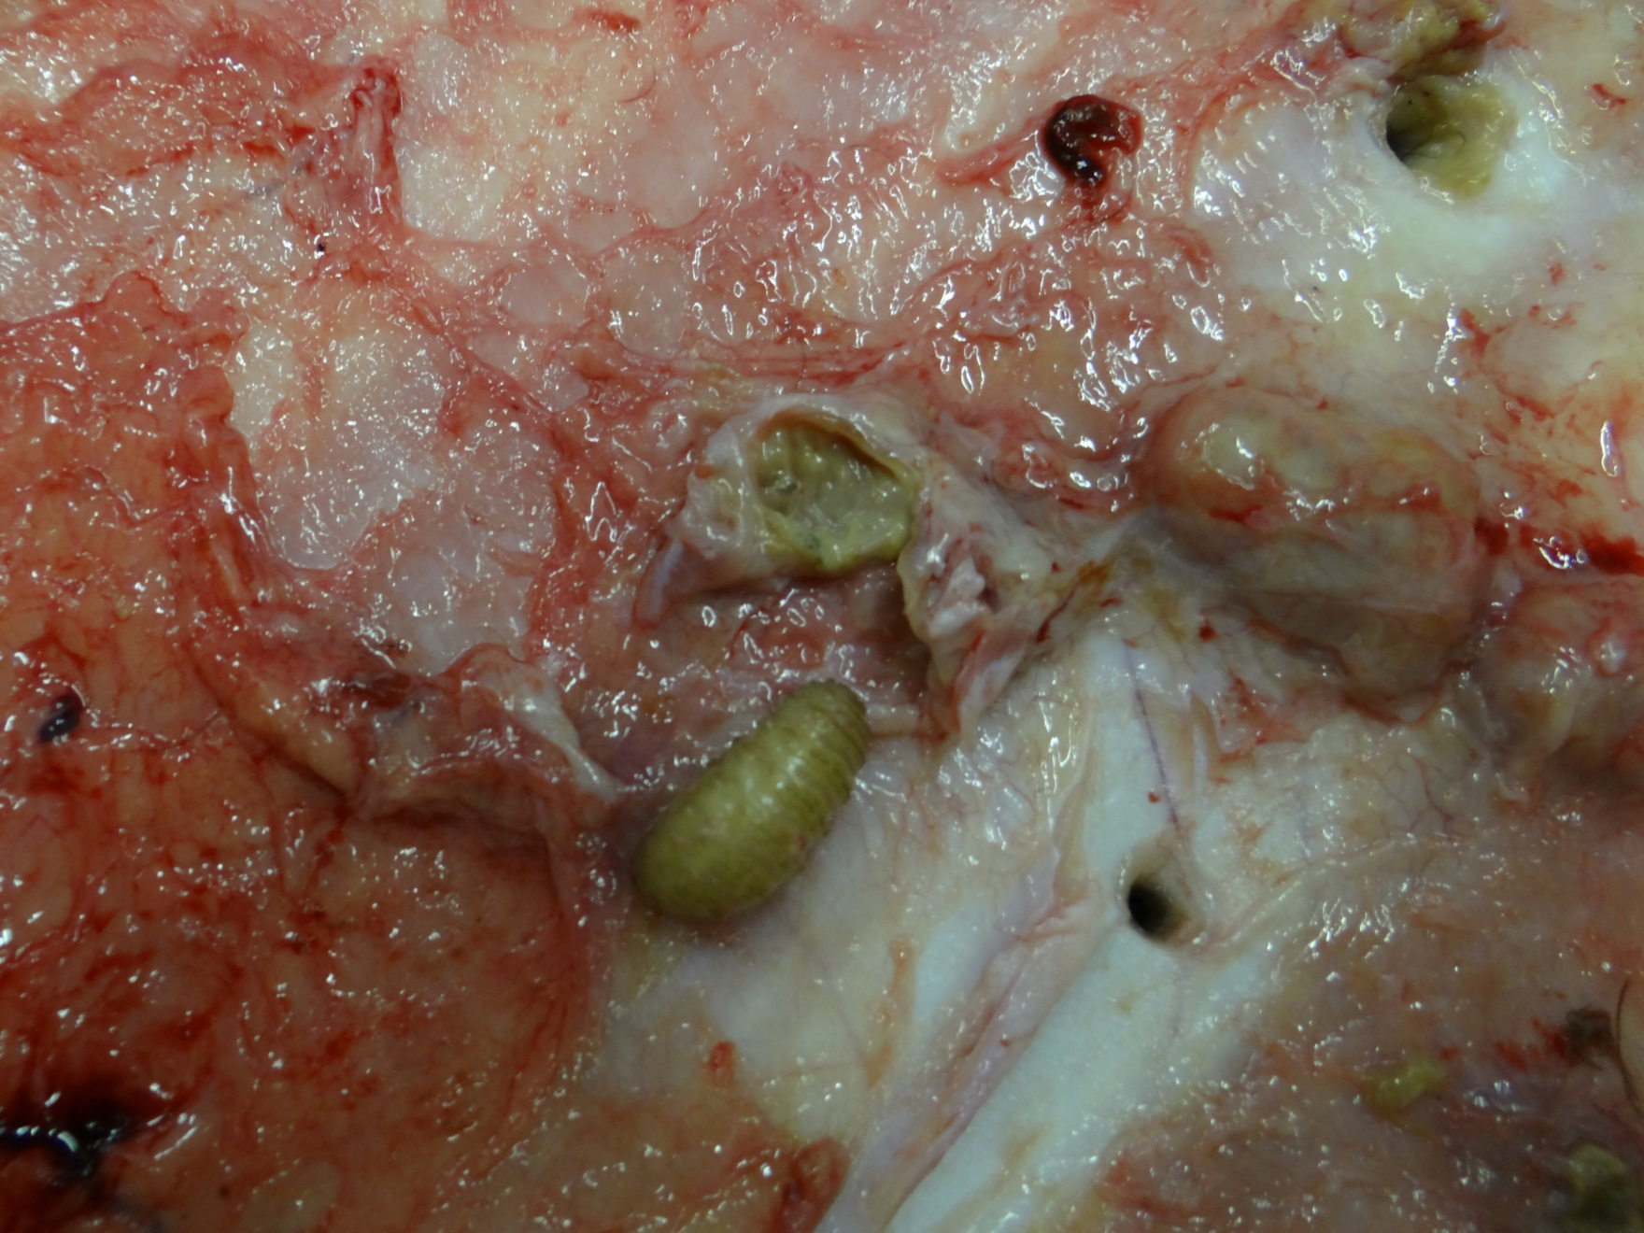

**Figure 3.1** Cattle grubs and hide damage in a feeder calf harvested at the WTAMU Meat Laboratory (d18).

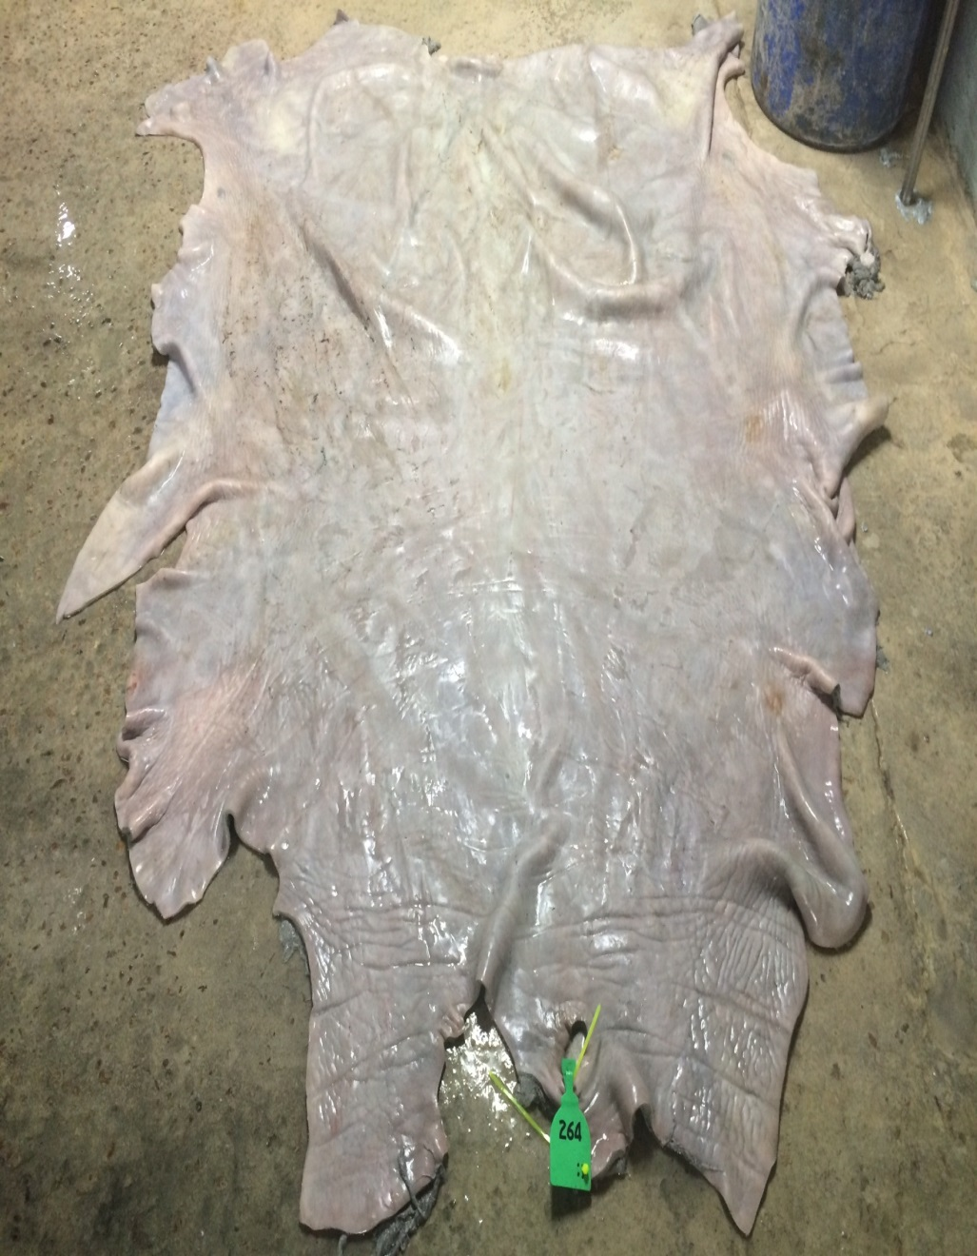

**Figure 3.5** Individually identified blue-chrome hide from a grub-free animal.

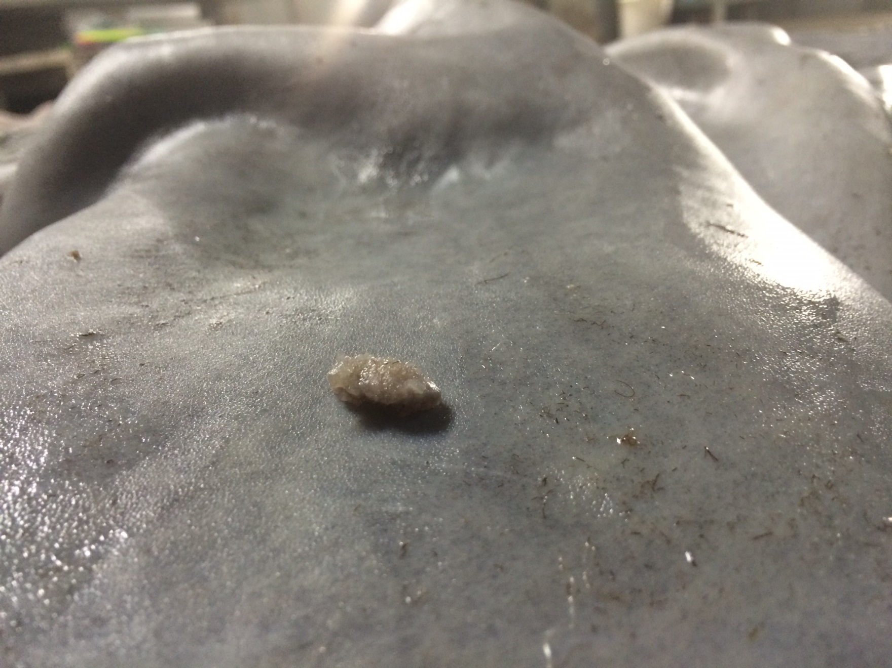

**Figure 3.6** Cattle grub on hide at slaughter (d264).

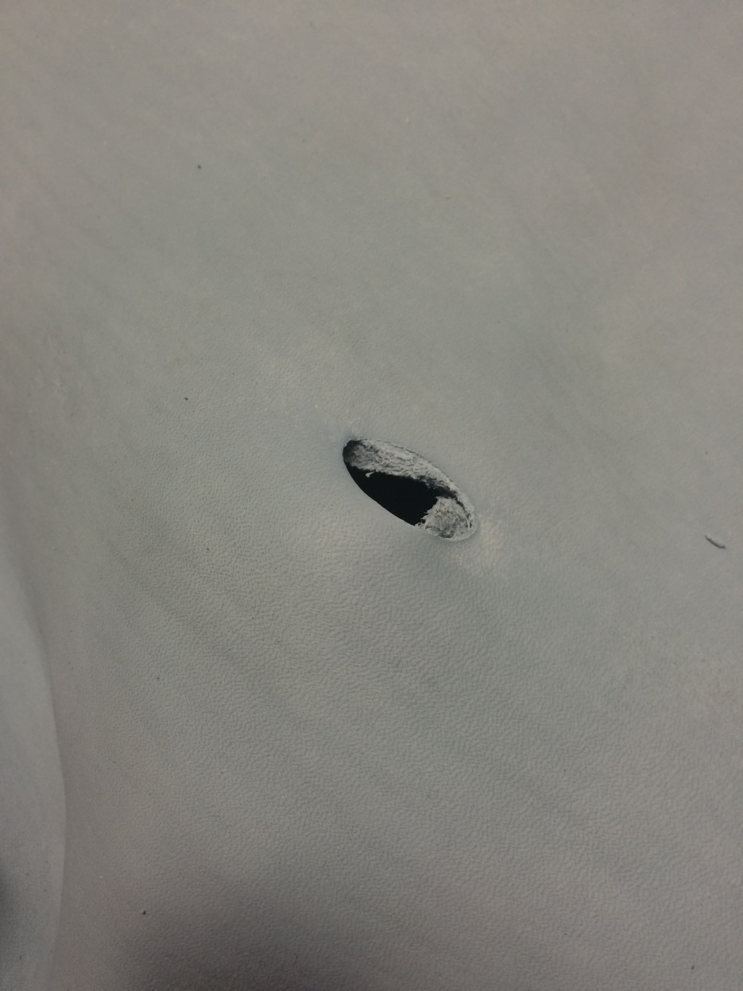

**Figure 3.7** Hole from cattle grub in blue-chrome hide at slaughter (d264).

# **APPENDICES**

# **Complete data on palpated grub hide maps, live cattle performance, slaughter data, and grade data**

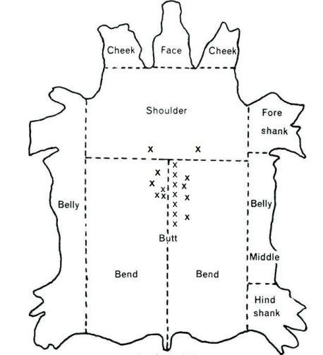

**Appendix A**

Animal 0015-017

Date Slaughtered: 7 July 2015

Total Grubs Palpated: 18

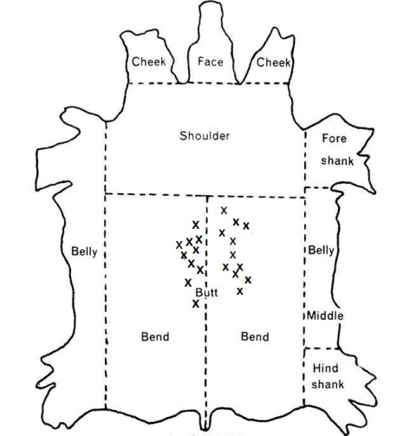

**Appendix B**

Animal 0015-018

Date Slaughtered: 7 July 2015

Total Grubs Palpated: 21

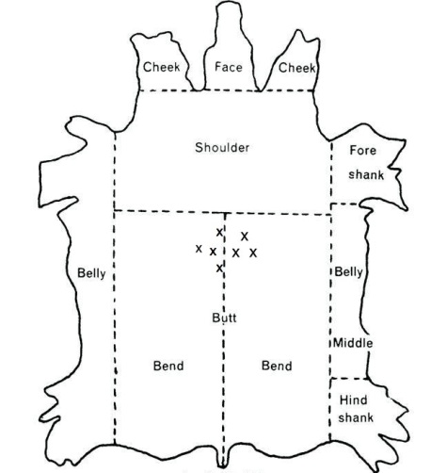

**Appendix C**

Animal 0015-019

Date Slaughtered: 5 August 2015

Total Grubs Palpated: 7

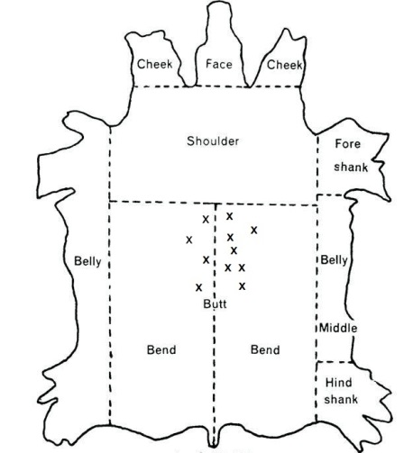

**Appendix D**

Animal 0015-020

Date Slaughtered: 5 August 2015

Total Grubs Palpated: 11

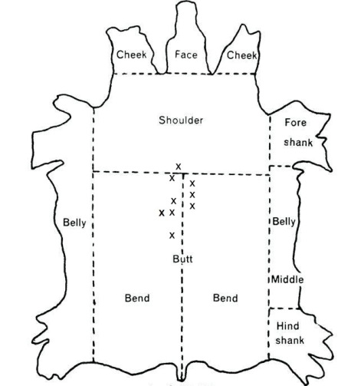

**Appendix E**

Animal 0015-021

Date Slaughtered: 2 December 2014 - Harvested at WTAMU Meat Laboratory

Total Grubs Palpated: 9

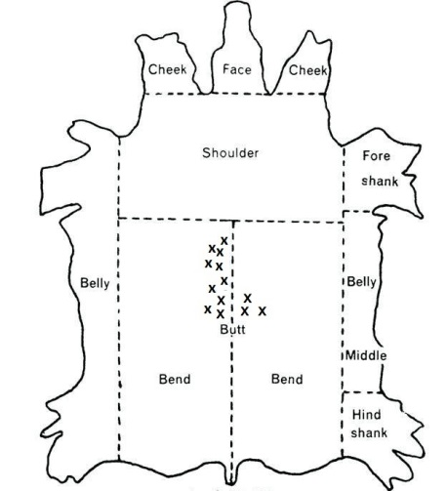

**Appendix F**

Animal 0015-022

Date Slaughtered: 5 August 2015

Total Grubs Palpated: 13

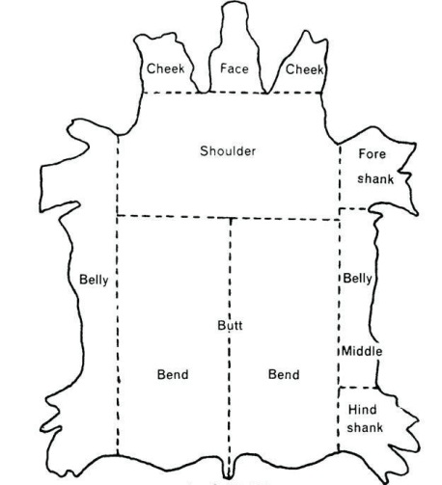

**Appendix G**

Animal 0015-023

Date Slaughtered: N/A - Died 03 January 2015 – WTAMU Research Feedlot

Total Grubs Palpated: 0 – Ticks Present

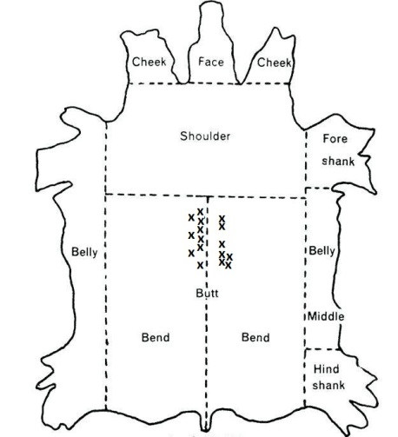

**Appendix H**

Animal 0015-024

Date Slaughtered: 7 July 2015

Total Grubs Palpated: 16

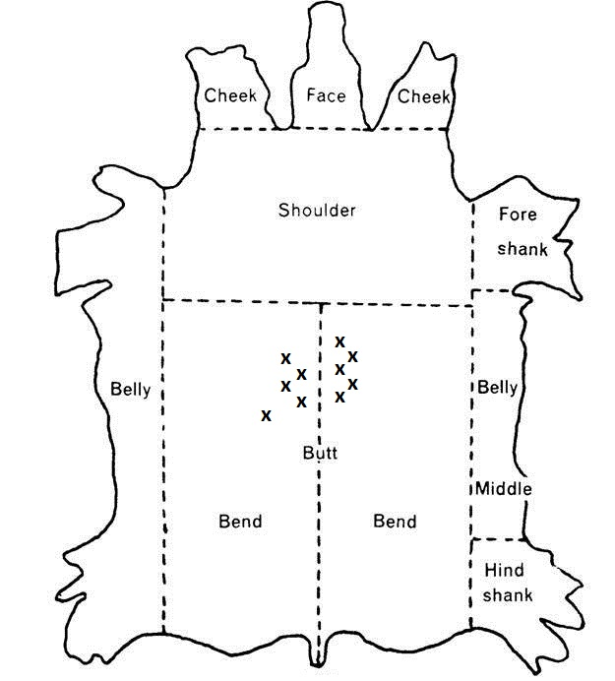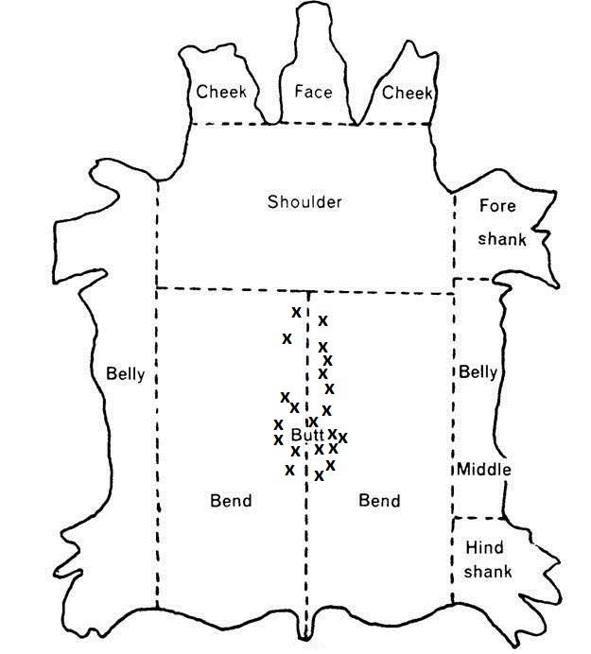

**Appendix I**

Animal 0016-037

Date Slaughtered: 5 August 2015

Total Grubs Palpated: 10

**Appendix J**

Animal 0016-038

Date Slaughtered: 5 August 2015

Total Grubs Palpated: 21

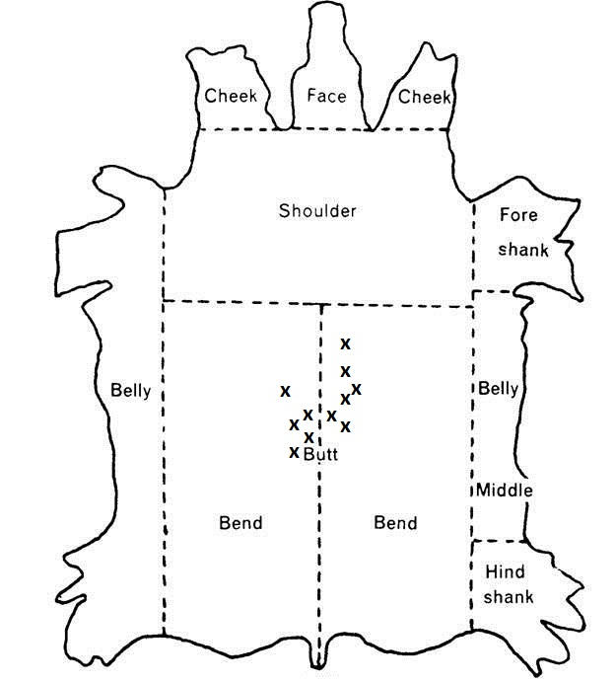

**Appendix K**

Animal 0016-039

Date Slaughtered: 7 July 2015

Total Grubs Palpated: 11

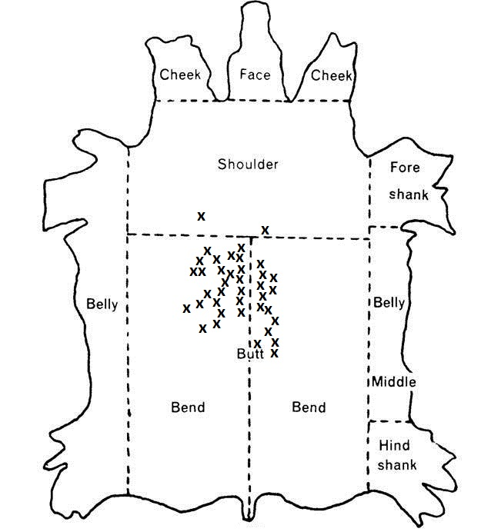

**Appendix L**

Animal 0016-040

Date Slaughtered: 5 August 2015

Total Grubs Palpated: 39

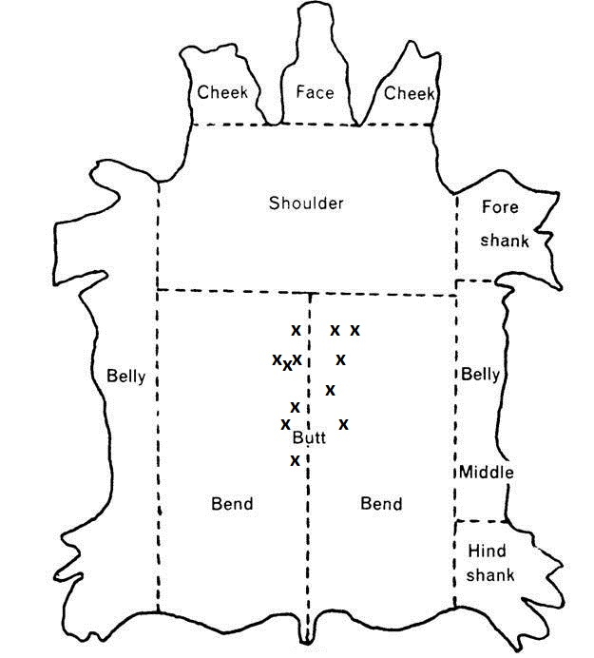

**Appendix M**

Animal 0016-041

Date Slaughtered: 5 August 2015

Total Grubs Palpated: 12

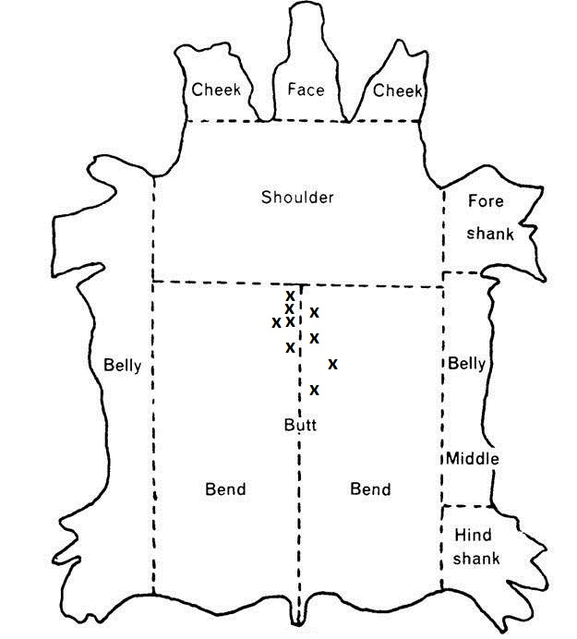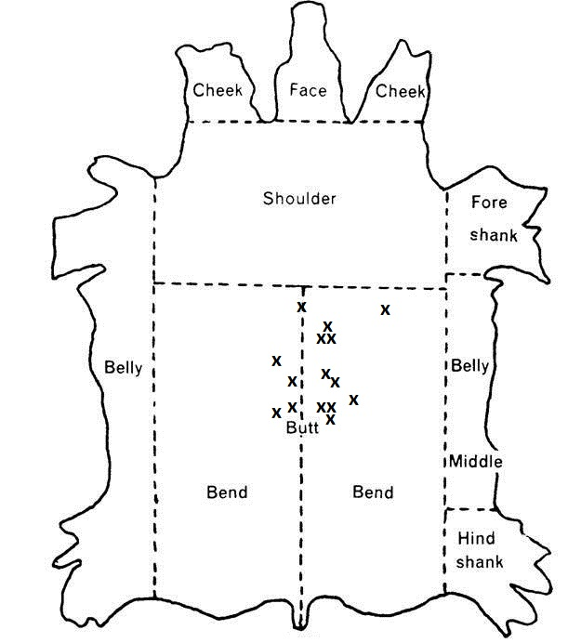

**Appendix N**

Animal 0016-042

Date Slaughtered: 5 August 2015

Total Grubs Palpated: 9

**Appendix O**

Animal 0016-043

Date Slaughtered: 5 August 2015

Total Grubs Palpated: 15

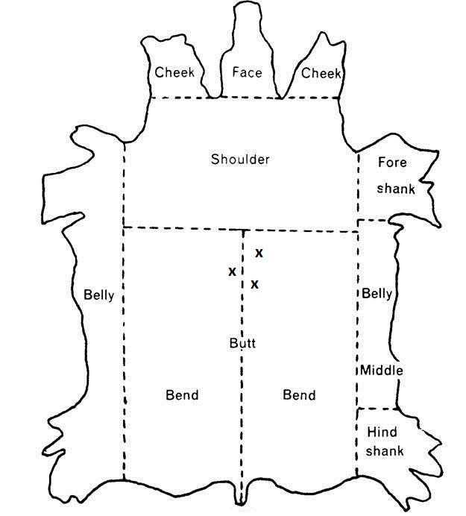

**Appendix P**

Animal 0016-044

Date Slaughtered: 7 July 2015

Total Grubs Palpated: 3

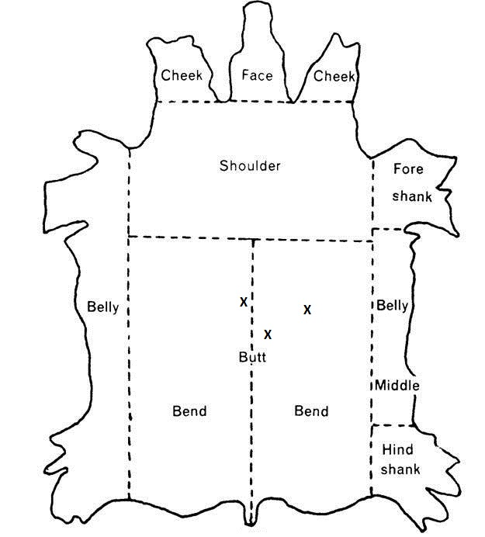

**Appendix Q**

Animal 0017-017

Date Slaughtered: 5 August 2015

Total Grubs Palpated: 3

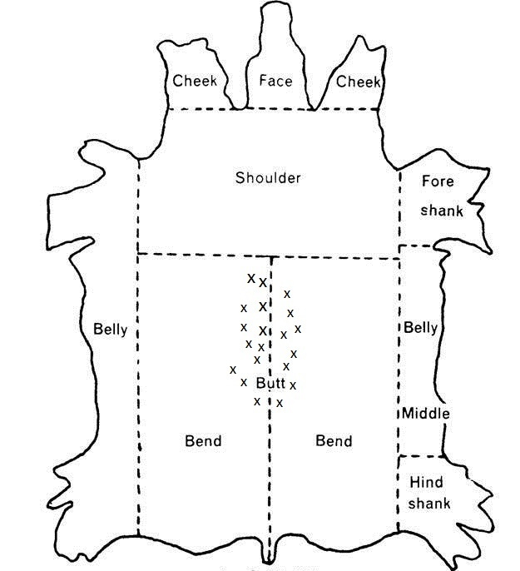

**Appendix R**

Animal 0017-018

Date Slaughtered: 2 December 2014 - Harvested at WTAMU Meat Laboratory

Total Grubs Palpated: 20

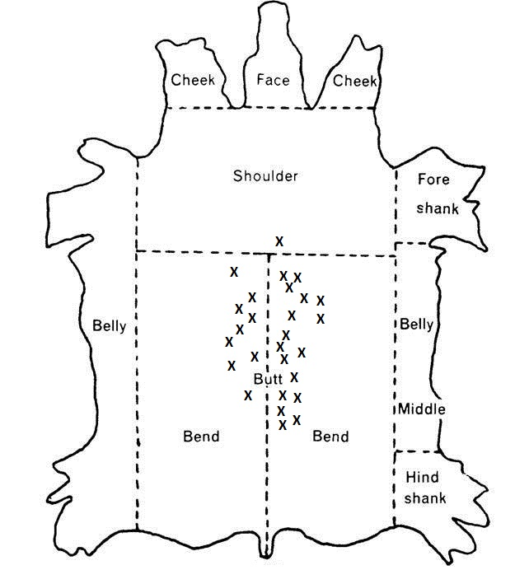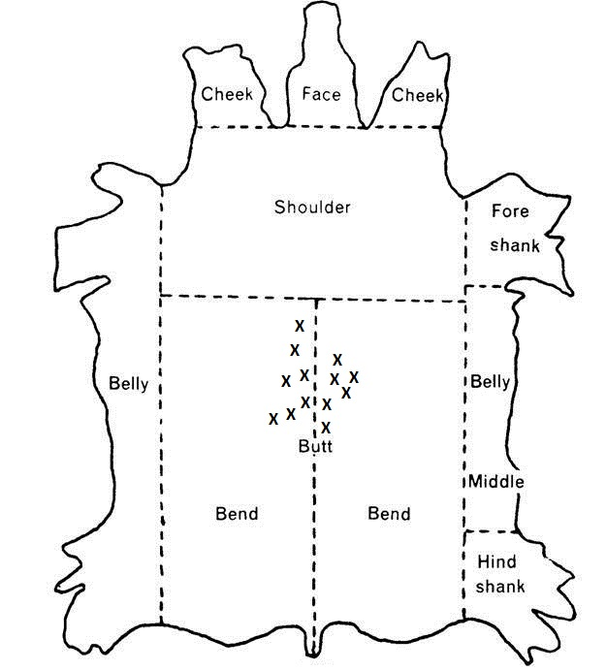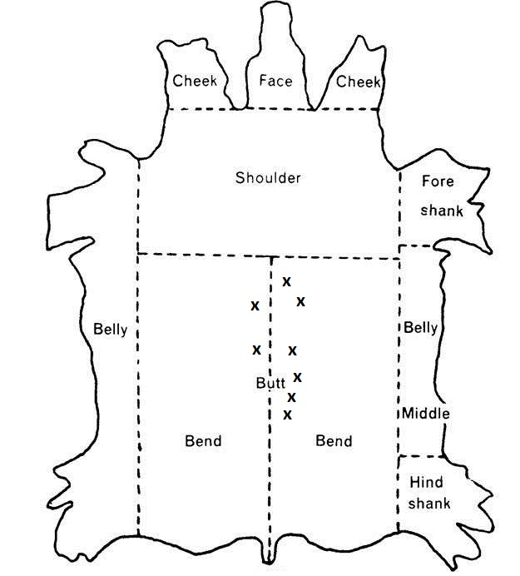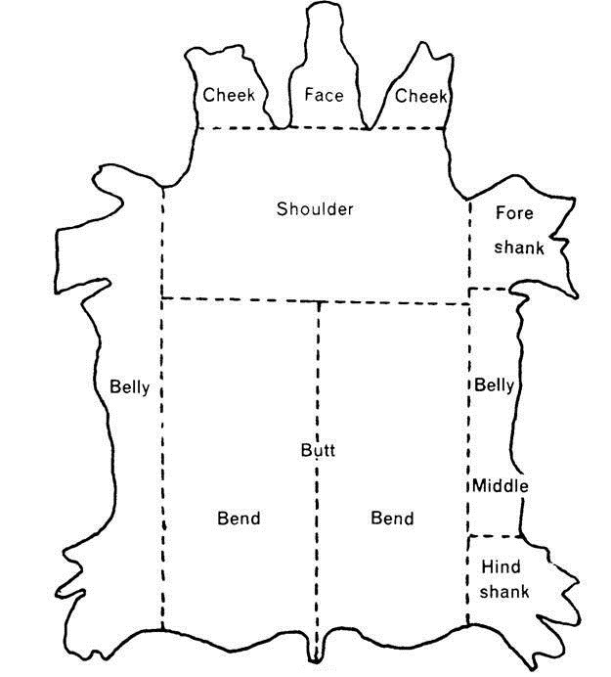

**Appendix S**

0017-019

Date Slaughtered: 7 July 2015

Total Grubs Palpated: 27

**Appendix T**

Animal 0017-020

Date Slaughtered: 5 August 2015

Total Grubs Palpated: 13

**Appendix U**

Animal 0017-021

Date Slaughtered: 7 July 2015

Total Grubs Palpated: 8

**Appendix V**

Animal 0017-022

Date Slaughtered: N/A – Died 29 November 2014 – WTAMU Research Feedlot

Total Grubs Palpated: 0

**Appendix W**

Animal 0017-023

Date Slaughtered: 7 July 2015

Total Grubs Palpated: 0

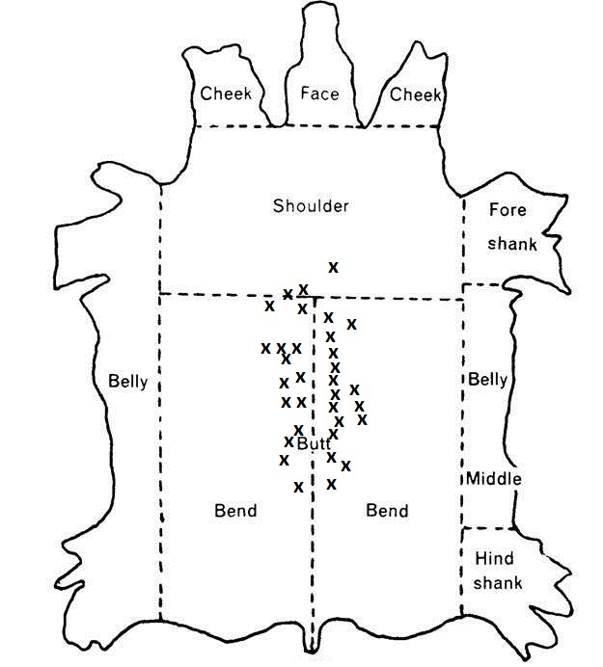

**Appendix X**

Animal 0017-024

Date Slaughtered: 5 August 2015

Total Grubs Palpated: 33



**Appendix Y**

Animal 0018-031

Date Slaughtered: 5 August 2015

Total Grubs Palpated: 0



**Appendix Z**

Animal 0018-032

Date Slaughtered: 5 August 2015

Total Grubs Palpated: 0



**Appendix AA**

Animal 0018-033

Date Slaughtered: 5 August 2015

Total Grubs Palpated: 0

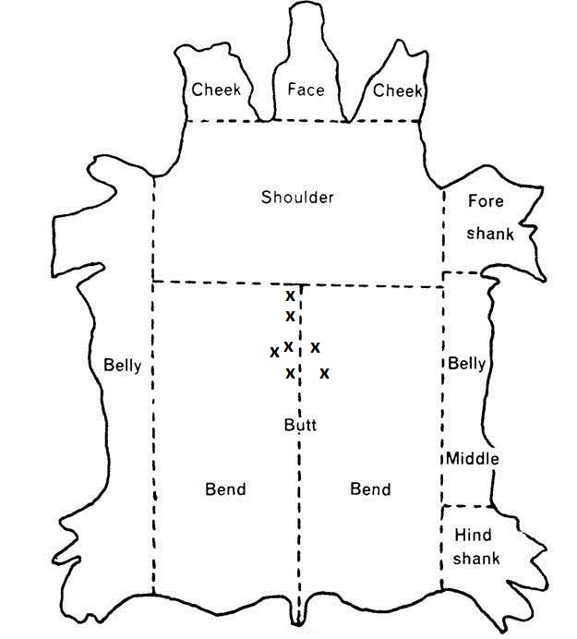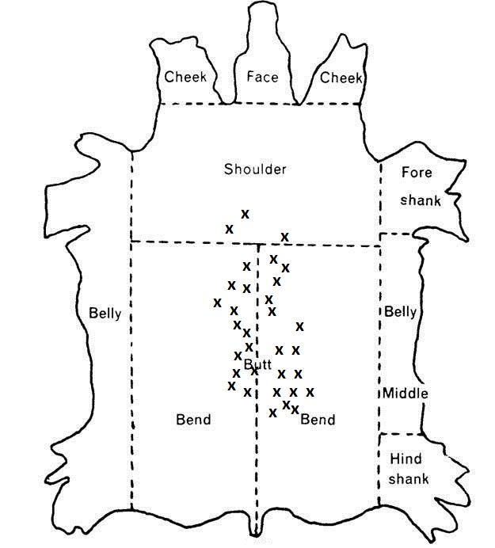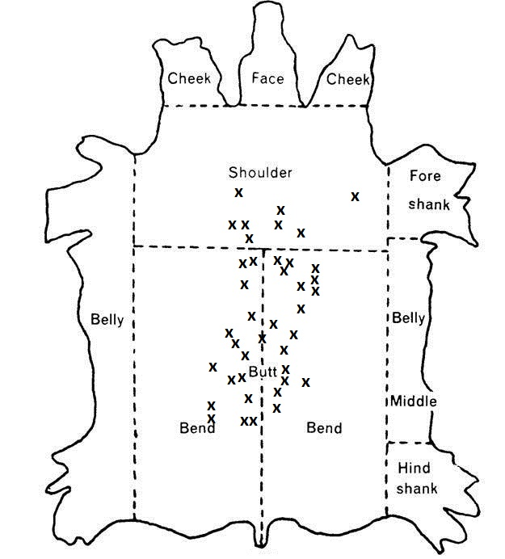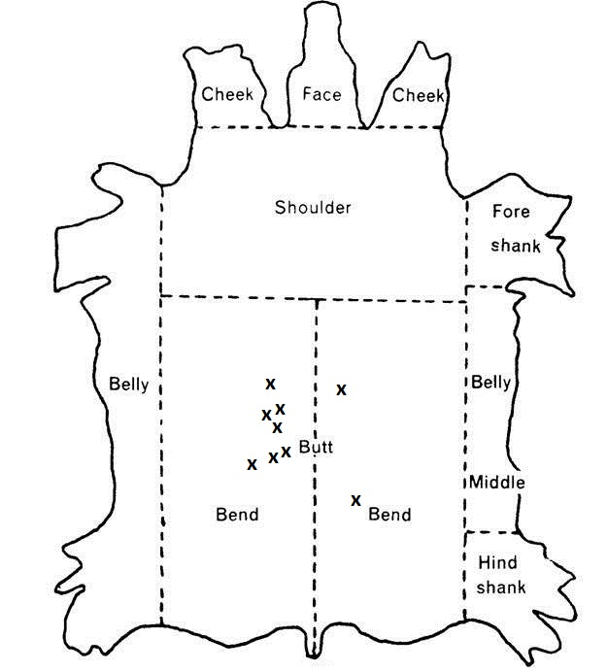

**Appendix BB**

Animal 0018-034

Date Slaughtered: 5 August 2015

Total Grubs Palpated: 0

**Appendix CC**

Animal 0018-035

Date Slaughtered: 5 August 2015

Total Grubs Palpated: 7

**Appendix DD**

Animal 0018-036

Date Slaughtered: 7 July 2015

Total Grubs Palpated: 32

**Appendix EE**

Animal 0018-037

Date Slaughtered: 5 August 2015

Total Grubs Palpated: 40

**Appendix FF**

Animal 0018-038

Date Slaughtered: 5 August 2015

Total Grubs Palpated: 9



**Appendix GG**

# 

**Appendix HH**

# 

**Appendix II**

# 

**Appendix JJ**

# 

# **SLAUGHTER 1**

**07 JUL 2015**

**TYSON FRESH MEATS**

**AMARILLO, TX.**



**Appendix KK**

# 

# **SLAUGHTER 2**

**05 AUG 2015**

**TYSON FRESH MEATS**

**AMARILLO, TX.**



**Appendix LL**